SMART DARSHAN – REAL-TIME QUEUE AND CROWD MANAGEMENT SYSTEM FOR TEMPLES
A PROJECT REPORT
Submitted by
MADHAV G (310624205131)
in partial fulfillment for the award of the Degree
of
BACHELOR OF TECHNOLOGY
in
INFORMATION TECHNOLOGY

EASWARI ENGINEERING COLLEGE,
(AN AUTONOMOUS INSTITUTION) – AFFILIATED TO ANNA UNIVERSITY,
CHENNAI
OCTOBER 2026

EASWARI ENGINEERING COLLEGE
BONAFIDE CERTIFICATE
Certified that this mini project report titled “SMART DARSHAN – REAL-TIME QUEUE AND CROWD MANAGEMENT SYSTEM FOR TEMPLES” is the Bonafide work of “MADHAV G (310624205131)”, who carried out the project work under my supervision.

HEAD OF THE DEPARTMENT | SUPERVISOR

EASWARI ENGINEERING COLLEGE
Certificate of Viva-voce-Examination
This is to certify that the Viva Voce Examination of the Project Work entitled “SMART DARSHAN – REAL-TIME QUEUE AND CROWD MANAGEMENT SYSTEM FOR TEMPLES” submitted by Mr./Ms. MADHAV G (Reg. No. 310624205131) in partial fulfillment of the requirements for the award of the degree of BACHELOR OF TECHNOLOGY was conducted on ____________ (Date) in the Department of Information Technology, Easwari Engineering College, Ramapuram – Chennai.

Internal Examiner  Name :  Designation :  Address : | External Examiner  Name :  Designation :  Address :

Date:

ABSTRACT
Devotees at temples and pilgrimage centres often wait for several hours because entry is managed manually and no reliable information about queue length or expected waiting time is available to them. This project, Smart Darshan, is a multi-temple web platform that replaces the physical waiting line with a slot-based virtual queue. Devotees book a darshan slot online, or collect a walk-in token at the temple counter or at a self-service kiosk, and receive a QR-coded digital token. The capacity of every slot is split into an online quota and a walk-in quota, and seats are reserved with a single atomic database update so that simultaneous bookings can never exceed the capacity of a slot.
The token is scanned at the entry and exit gates. These scans keep the live count of devotees in each darshan lane accurate, and a wait-time engine estimates the waiting time from the number of devotees in the queue and the service rate measured at the exit gate. Live queue status is pushed instantly over Socket.IO to the devotee’s phone, to entry display boards and to the administrator dashboard, and is also available by SMS for devotees without smartphones. A prediction module built with Python and scikit-learn trains a Random Forest model for each temple on hourly footfall history, forecasts the crowd for every hour of the day and recommends the least crowded hours; on the demonstration data it achieved an R² of 0.90 to 0.94, with 15 to 26 per cent lower error than a weekday-hour average baseline. Administrators are alerted when the queue reaches 90 and 100 per cent of the safe limit and can pause entry at all gates instantly.
The system is built with MongoDB, Express.js, React and Node.js (the MERN stack) and was verified with 49 automated end-to-end API checks and a live gate simulator. The result is shorter, planned waiting and transparent real-time queue information for every devotee.
Keywords: virtual queue, crowd management, real-time systems, QR code, MERN stack, Socket.IO, Random Forest regression.

ACKNOWLEDGEMENT
I express my sincere gratitude to the Principal Dr. P. Deiva Sundari and the Management of our college for providing me with the opportunity to carry out this project work.
I convey my heartfelt thanks to the Head of the Department, Department of Information Technology, for the continuous encouragement and support.
I am extremely thankful to my Project Guide, G. Sai Lakshmi, Department of Information Technology, for valuable guidance, suggestions, and motivation throughout the completion of this project.
I would also like to extend my gratitude to all the faculty members of the Department of Information Technology for their support.
Finally, I thank my parents and friends for their constant encouragement and help during the course of this project.

MADHAV G
(310624205131)

TABLE OF CONTENTS
CHAPTER NO. | TITLE | PAGE No.
 | ABSTRACT | 4
 | LIST OF FIGURES | 7
 | LIST OF TABLES | 8
1 | INTRODUCTION | 9
 | 1.1 OVERVIEW | 9
 | 1.2 PROBLEM DEFINITION | 9
 | 1.3 OBJECTIVE | 10
 | 1.4 SCOPE OF THE PROJECT | 11
 | 1.5 MOTIVATION | 11
2 | RELATED WORK | 13
 | 2.1 LITERATURE REVIEW | 13
 | 2.2 EXISTING SYSTEM | 14
 | 2.3 PROPOSED SYSTEM | 15
3 | SYSTEM ANALYSIS | 18
 | 3.1 SYSTEM REQUIREMENTS | 18
 | 3.2 SOFTWARE AND HARDWARE REQUIREMENTS | 20
4 | SYSTEM DESIGN | 22
 | 4.1 SYSTEM ARCHITECTURE | 22
 | 4.2 MODULE DESCRIPTION | 23
 | 4.3 DATABASE DESIGN | 25
 | 4.4 CLASS DIAGRAM | 27
 | 4.5 SEQUENCE DIAGRAM | 28
5 | IMPLEMENTATION | 31
 | 5.1 IMPLEMENTATION OVERVIEW | 31
 | 5.2 KEY FUNCTIONS (CODE EXPLANATION) | 32
 | 5.3 TESTING AND RESULTS | 40
6 | CONCLUSION & FUTURE WORK | 43
 | 6.1 CONCLUSION | 43
 | 6.2 FUTURE ENHANCEMENTS | 43
 | APPENDIX | 45
 | SCREENSHOTS OF THE PROJECT | 65
 | REFERENCES | 78

LIST OF FIGURES
FIG. NO. | TITLE | PAGE No.
2.1 | Devotee journey in the proposed system | 16
3.1 | Use case diagram of Smart Darshan | 18
4.1 | System architecture of Smart Darshan | 22
4.2 | Database design (entity–relationship diagram) | 26
4.3 | Class diagram | 28
4.4 | Sequence diagram – online booking and QR-verified entry | 29
4.5 | Sequence diagram – crowd forecast and model retraining | 30
5.1 | Token life cycle (state diagram) | 34
5.2 | Wait-time engine | 36
5.3 | Crowd prediction pipeline | 38
5.4 | Prediction error of the model compared with the baseline | 42
S.1 | Home page with the live waiting time of each temple | 65
S.2 | Login page | 65
S.3 | Temple page – live queue of each darshan lane | 66
S.4 | Temple page – hourly crowd forecast, darshan types and announcements | 66
S.5 | Booking a darshan slot with crowd-coloured time slots | 67
S.6 | My tokens – QR-coded digital token | 68
S.7 | Live token status – queue position and estimated wait | 68
S.8 | Entry display board | 69
S.9 | Self-service kiosk – choosing a darshan type | 69
S.10 | Self-service kiosk – token issued with QR code | 70
S.11 | Walk-in counter | 70
S.12 | QR gate scanner – entry recorded | 71
S.13 | Crowd dashboard | 71
S.14 | Crowd dashboard – occupancy, actual versus predicted footfall and live lanes | 72
S.15 | Crowd dashboard – slot bookings and an occupancy alert | 72
S.16 | Analytics – prediction model accuracy and feature importance | 73
S.17 | Analytics – 7-day crowd forecast | 73
S.18 | Analytics – crowd trends and daily visitors | 74
S.19 | Analytics – busiest days and hours | 74
S.20 | Darshan slot management | 75
S.21 | Announcements | 76
S.22 | Staff accounts | 76
S.23 | Temple settings | 77
S.24 | Superadmin – all temples | 77

LIST OF TABLES
TABLE NO. | TITLE | PAGE No.
2.1 | Summary of the literature survey | 14
3.1 | Functional requirements | 19
3.2 | Hardware requirements | 20
3.3 | Software requirements | 20
4.1 | Database collections | 26
5.1 | Main REST API endpoints | 31
5.2 | Automated end-to-end test coverage | 40
5.3 | Prediction model results (test set) | 41

CHAPTER 1
INTRODUCTION

1.1 OVERVIEW
Temples and pilgrimage centres in India receive thousands of devotees every day, and the number multiplies during festivals, weekends and auspicious days. In most temples entry is regulated manually with physical queue lines and barricades, so devotees have no way of knowing how long they must wait or when the temple will be less crowded. The result is long waiting in the open, congestion at the entrance and avoidable discomfort, especially for elderly devotees, children and differently-abled visitors.
Smart Darshan is a software-only solution to this problem. It is a multi-temple web platform in which every darshan entry is represented by a digital token that belongs to a time slot. Devotees can book a slot online up to seven days in advance, or simply walk in and collect a token from the counter or the self-service kiosk at the temple. Gate staff scan the QR code on the token with an ordinary phone or webcam at the entry and exit gates, and these scans drive a live picture of every queue. From this picture the system computes the waiting time for each darshan lane and publishes it in real time to devotees, display boards and temple administrators.
The platform is built on the MERN stack. MongoDB stores temples, slots, tokens and hourly footfall; a Node.js and Express.js server exposes a REST API and a Socket.IO channel for live updates; and a React application provides the devotee website, the gate staff console, the kiosk, the display board and the administrator dashboards. A separate Python service trains a machine-learning model for each temple to forecast hourly crowd levels and recommend the best time to visit.

1.2 PROBLEM DEFINITION
The problem addressed by this project is stated as follows:
“Devotees experience long waiting times due to unplanned crowd management and lack of real-time queue information.”
Analysing this statement in the context of a typical temple gives the following specific problems:
- No real-time queue information – devotees cannot see how many people are ahead of them or how long the wait will be, either before leaving home or while standing in line.
- Unplanned arrivals – arrivals are not spread over the day, so the morning and evening peaks overload the entrance while other hours remain under-used.
- Uncoordinated online and walk-in entry – where advance booking exists it is managed separately from devotees who walk in, so the total number admitted per hour is not controlled.
- Reactive crowd control – staff open or close gates only after congestion has built up, because they have neither a live count nor an early warning.
- No data for planning – footfall is not recorded digitally, so administrators cannot predict peak days or plan counters, staff and festival arrangements.
The project therefore has to provide accurate live queue information, spread arrivals across the day and give administrators the tools to act before congestion builds, without depending on special hardware at the temple.

1.3 OBJECTIVE
The objectives of Smart Darshan are:
- To replace the physical waiting line with a slot-based virtual queue that serves both online bookings and walk-in devotees from a shared, controlled capacity.
- To issue every devotee a QR-coded digital token that is verified at the entry and exit gates, so that the number of devotees in each queue is always known.
- To estimate the waiting time of each darshan lane from live gate data and deliver it in real time through the web application, display boards and SMS.
- To forecast hourly crowd levels with a machine-learning model trained on footfall history and recommend the least crowded hours to visit.
- To give temple administrators a live crowd dashboard with occupancy alerts at 90 % and 100 % of the safe limit and the ability to pause entry instantly.
- To support multiple temples on one platform with secure, role-based access for devotees, gate staff, temple administrators and a platform superadmin.
- To achieve all of the above purely in software, using only the phones and computers that temples and devotees already have.

1.4 SCOPE OF THE PROJECT
The scope covers the complete workflow of darshan entry at one or more temples:
- Onboarding of temples by a superadmin, with darshan types (general, special/paid and a senior-citizen and differently-abled priority lane), opening hours, festival calendar and crowd rules configured by each temple’s administrator.
- Automatic generation of time slots for a seven-day booking window, with extra capacity on festival days.
- Online booking for groups of up to six people, a walk-in counter with printable token slips, and a self-service token kiosk.
- QR scanning at the entry and exit gates using the camera of a phone or laptop through the browser.
- Live status, queue position and waiting time for every token; entry display boards; SMS notifications and SMS queries.
- An administrator dashboard with analytics, crowd forecasting, occupancy alerts and entry control.
The following are outside the scope of this version: online payment for paid darshan types (the price is shown but not collected), physical turnstiles or sensors, native mobile applications (the responsive web application is used on phones instead) and deployment at a live temple. The system was evaluated with three demonstration temples, 90 days of synthetic footfall history and a gate simulator.

1.5 MOTIVATION
Religious gatherings in India are among the largest crowds anywhere, and managing the flow of devotees at sacred places has been highlighted as an area where planning and technology are urgently needed [5]. Research on virtual queues in other domains has studied how telling people the expected delay changes the way they wait [4]. Yet at most temples the devotee experience is still a long, uncertain physical line.
This project is motivated by three observations. First, almost every devotee and every temple office already has a smartphone or a computer, so a software-only system can be deployed without installing any hardware. Second, the information needed to run a queue fairly – who has entered, who has left and how fast the line is moving – can be captured with a single QR scan at each gate. Third, temple crowds follow strong daily, weekly and festival patterns, so a modest amount of recorded history is enough to forecast crowds and advise devotees on the best time to visit. Smart Darshan brings these ideas together into one platform.

CHAPTER 2
RELATED WORK

2.1 LITERATURE REVIEW
Crowd management at religious sites has been approached from two directions: measuring the crowd that is already present, and controlling how many people arrive. The works most relevant to this project are reviewed below and summarised in Table 2.1.
2.1.1 Crowd density estimation using deep learning
Bhuiyan et al. [1] applied a convolutional neural network (CNN) based crowd-counting model to video footage of the Hajj pilgrimage to estimate density in very dense gatherings. The approach measures density automatically without manual head counting, but it needs dense camera coverage and GPU hardware, and it reports how crowded an area is rather than how long an individual devotee will have to wait.
2.1.2 IoT-based temple crowd management
Kawade et al. [2] proposed a temple crowd management system that uses infrared, ultrasonic and air-quality sensors with servo-controlled gates to monitor devotee flow and congestion at each gate in real time. The system gives administrators live information, but it requires sensor hardware at every gate and gives devotees no queue position or advance booking.
2.1.3 Slot-based darshan management
Reddy et al. [3] developed a slot-based darshan management system in which devotees book QR-verified time slots and administrators are given predictive analytics. Booked slots spread arrivals across the day and reduce physical queueing; however, the system depends on smartphone access and does not count devotees at the gate, so the waiting time is not updated continuously.
2.1.4 Delay information in virtual queues
Yu, Zhang and Zhou [4] carried out a large-scale field experiment on a major ride-sharing platform to study how the delay information shown to customers waiting in a virtual queue influences their waiting behaviour. Their work supports a central idea of this project: an accurate, continuously updated waiting time is valuable to the person waiting, not only to the operator.
2.1.5 Crowd management at India’s sacred spaces
The KPMG in India report “Faith and Flow” [5] examines the scale of crowds at India’s religious sites and the role of planning, real-time monitoring and digital tools in managing them safely, which frames the practical need addressed here.
Table 2.1: Summary of the literature survey
Author | Year | Description | Pros | Cons
Bhuiyan et al. [1] | 2022 | CNN-based crowd counting on Hajj pilgrimage video to estimate density in very dense gatherings. | Measures crowd density automatically, without manual head counting. | Needs dense camera coverage and GPU hardware; reports density, not individual waiting time.
Kawade et al. [2] | 2025 | IoT-based temple crowd management using IR, ultrasonic and air-quality sensors with servo-controlled gates. | Monitors devotee flow and congestion at each gate in real time. | Requires sensor hardware at every gate; no queue position or advance slot booking for devotees.
Reddy et al. [3] | 2026 | Slot-based darshan management with QR-verified time slots and predictive analytics for administrators. | Spreads arrivals across booked slots and reduces physical queueing. | Depends on smartphone access; no live gate-level counting to update waiting time continuously.

None of the reviewed works combines, in one system, advance slots and walk-ins drawn from a single controlled capacity, gate-level counting without special hardware, a continuously updated waiting time for each lane, and crowd forecasting across many temples. Smart Darshan is designed to fill this gap.

2.2 EXISTING SYSTEM
Crowd handling at most temples today is manual. Devotees stand in physical queue lines regulated by staff and barricades, and entry is controlled by opening or closing gates as the crowd builds up. Some large temples issue paper tokens at a counter, and a few offer online portals that only confirm a darshan date and time. The commonly used approaches are:
- Manual queue and barricade management – staff physically regulate devotee flow, but decisions are reactive and depend on individual judgement.
- Counter-issued paper tokens – devotees collect a token at the temple itself, which still requires them to travel early and wait on site.
- Online slot booking portals – allow advance booking of a date and time, but give no live queue position or updated waiting time.
- CCTV-based visual monitoring – staff watch camera feeds to judge congestion manually, without any automatic counting or alerting.
Disadvantages of the existing system
- No real-time queue information – devotees cannot see their queue position or expected waiting time, so they wait without any idea of how long it will take.
- Unplanned crowd distribution – arrivals are not spread across the day, causing heavy congestion at peak hours while other hours remain under-used.
- Reactive manual control – gate and counter decisions are taken by staff only after congestion has already built up, not before it occurs.
- Poor accessibility and safety – elderly devotees, children and differently-abled visitors are forced to stand in long physical lines, increasing health and stampede risks.
- No data for planning – footfall is not recorded digitally, so administrators have no reliable basis to forecast peak days or plan staff and counters.

2.3 PROPOSED SYSTEM
The proposed system replaces physical waiting with a slot-based virtual queue. Devotees book a darshan slot through the web application on their phone or computer, or collect a token at the counter or kiosk, and receive a QR-coded digital token instead of standing in a line. Online bookings and walk-ins draw on the same slot capacity: each slot keeps an online quota and a walk-in quota, and online seats that are still unsold shortly before the slot starts are released to walk-in devotees.
At the entry gate the token is scanned, which adds the devotee’s group to the live queue of that darshan lane; the exit scan removes them. The wait-time engine computes the estimated waiting time from the number of devotees in the queue and the service rate measured at the exit gate, and pushes it to the devotee’s phone, to display boards and to the administrator dashboard through real-time Socket.IO updates; devotees with basic phones can ask for it by SMS. Fig 2.1 shows this journey.
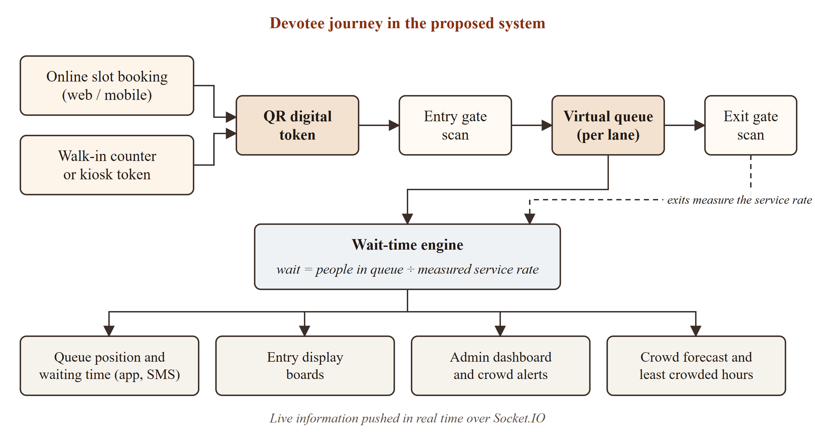
Fig 2.1: Devotee journey in the proposed system
A prediction module trained on historical footfall forecasts the crowd for every hour and recommends the least crowded slots, while the administrator dashboard shows live lane-wise crowd status, raises alerts at 90 % and 100 % of the safe limit and lets staff pause entry before congestion builds.
Advantages of the proposed system
- Reduced waiting time – slot-based virtual tokens spread arrivals across the day and remove long physical queues at the entrance.
- Real-time transparency – devotees see their live queue position and estimated waiting time on the app, on display boards or by SMS.
- Proactive crowd control – the dashboard, occupancy alerts and peak-hour forecast let staff act before congestion builds instead of reacting after it.
- Fair capacity for everyone – online and walk-in devotees share one controlled capacity, and a separate priority lane serves senior citizens and differently-abled visitors.
- Inclusive access – SMS and kiosk tokens cover devotees without smartphones.
- Data-driven planning – digitally recorded footfall gives administrators reliable data to plan counters, staff and festival arrangements.

CHAPTER 3
SYSTEM ANALYSIS

3.1 SYSTEM REQUIREMENTS
The requirements were derived from the problem definition and from the four kinds of users of the system: devotees, gate staff, temple administrators and the platform superadmin. Fig 3.1 shows these actors and the use cases available to each of them.
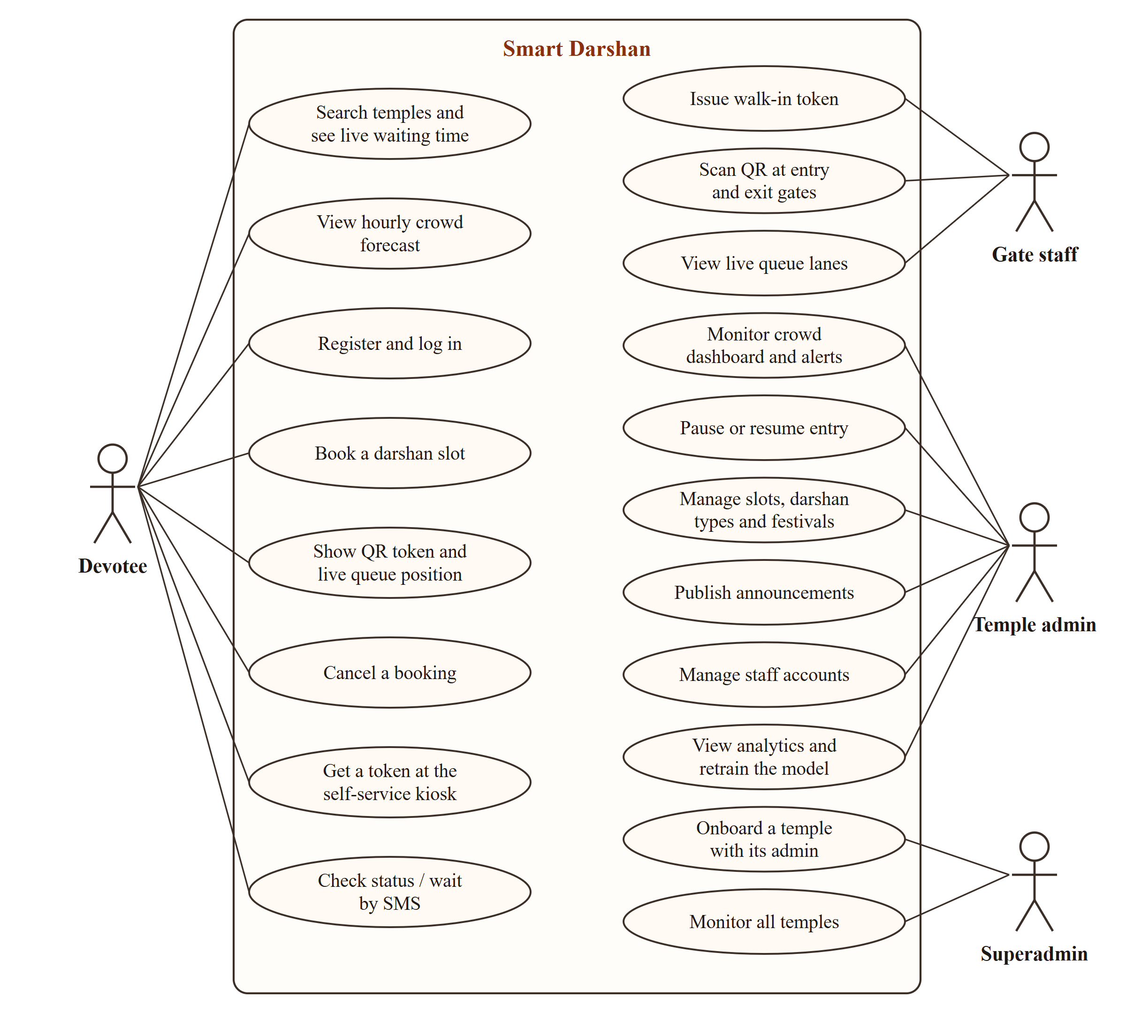
Fig 3.1: Use case diagram of Smart Darshan
3.1.1 Functional requirements
Table 3.1: Functional requirements
ID | Requirement
FR1 | Devotees can register, log in and update their profile; passwords are stored only as bcrypt hashes.
FR2 | Anyone can browse temples with the live waiting time, darshan types, announcements and the hourly crowd forecast.
FR3 | Devotees can book a slot for a group of up to six people (at most two bookings per temple per day) and cancel it before the slot starts.
FR4 | Gate staff can issue walk-in tokens at the counter, and devotees can issue themselves a token at the self-service kiosk.
FR5 | Gate staff can scan tokens at the entry and exit gates; invalid scans are rejected with a clear reason.
FR6 | Every token has a live status page showing its queue position and estimated waiting time.
FR7 | Entry display boards show the live waiting time of each lane and the least crowded hours of the day.
FR8 | Devotees receive SMS for bookings, reminders and cancellations, and can query a token or a temple’s waiting time by SMS.
FR9 | Temple administrators see a live crowd dashboard, receive occupancy alerts and can pause or resume entry at all gates.
FR10 | Temple administrators manage darshan types, timings, festivals, crowd rules, slots, announcements and staff accounts.
FR11 | The system forecasts hourly crowd for each temple and retrains the model nightly or on demand.
FR12 | A superadmin can onboard a new temple with its administrator account and monitor every temple on the platform.

3.1.2 Non-functional requirements
- Real-time behaviour – a gate scan should appear on dashboards, display boards and token pages within about a second; bursts of scans are combined into one update every 400 ms.
- Consistency – concurrent bookings and walk-ins must never exceed the capacity of a slot.
- Security – hashed passwords, signed JSON Web Tokens (valid for 7 days), role checks, temple scoping, rate-limited login and registration, validation of every request and standard HTTP security headers.
- Availability – forecasts fall back to historical averages if the prediction service is unavailable, and the API keeps retrying the database connection at start-up.
- Usability – responsive pages for phones, a large-button kiosk and a high-contrast display board readable from a distance.
- Portability and maintainability – runs on Windows, Linux or macOS; MongoDB can be local or MongoDB Atlas; the code is organised into routes, controllers and services and covered by automated end-to-end tests.

3.2 SOFTWARE AND HARDWARE REQUIREMENTS
The hardware and software required to develop and run the system are listed in Table 3.2 and Table 3.3. A webcam or a phone camera is the only device needed at a gate; no sensors or special hardware are used.
Table 3.2: Hardware requirements
Component | Specification
Processor | Intel Core i3 / 2.5 GHz or above
RAM | 4 GB minimum, 8 GB recommended
Hard disk | 40 GB
Input devices | Keyboard; webcam or smartphone camera for QR scanning
Monitor | Minimum resolution 1920 × 1080

Table 3.3: Software requirements
Category | Software
Operating system | Windows 10 or above (also runs on Linux and macOS)
Programming languages | JavaScript (Node.js 20+, ES modules), Python 3.10
Platform and tools | VS Code, Node.js 22, npm, MongoDB 7 or later (local or MongoDB Atlas), Git
Frontend | React 19, Vite 8, Tailwind CSS 4, React Router 7, Recharts 3, Socket.IO client, html5-qrcode, qrcode.react, Axios
Backend | Express 5, Socket.IO 4, Mongoose 9, jsonwebtoken, bcryptjs, zod, node-cron, helmet, express-rate-limit, Twilio SDK
Prediction service | Flask, scikit-learn, pandas, NumPy, joblib
External service | Twilio SMS API (optional; messages are logged to the console when not configured)
Browser | Google Chrome, Microsoft Edge or Mozilla Firefox (camera permission for QR scanning)

CHAPTER 4
SYSTEM DESIGN

4.1 SYSTEM ARCHITECTURE
Smart Darshan follows a three-tier client–server architecture with an additional machine-learning service, as shown in Fig 4.1.
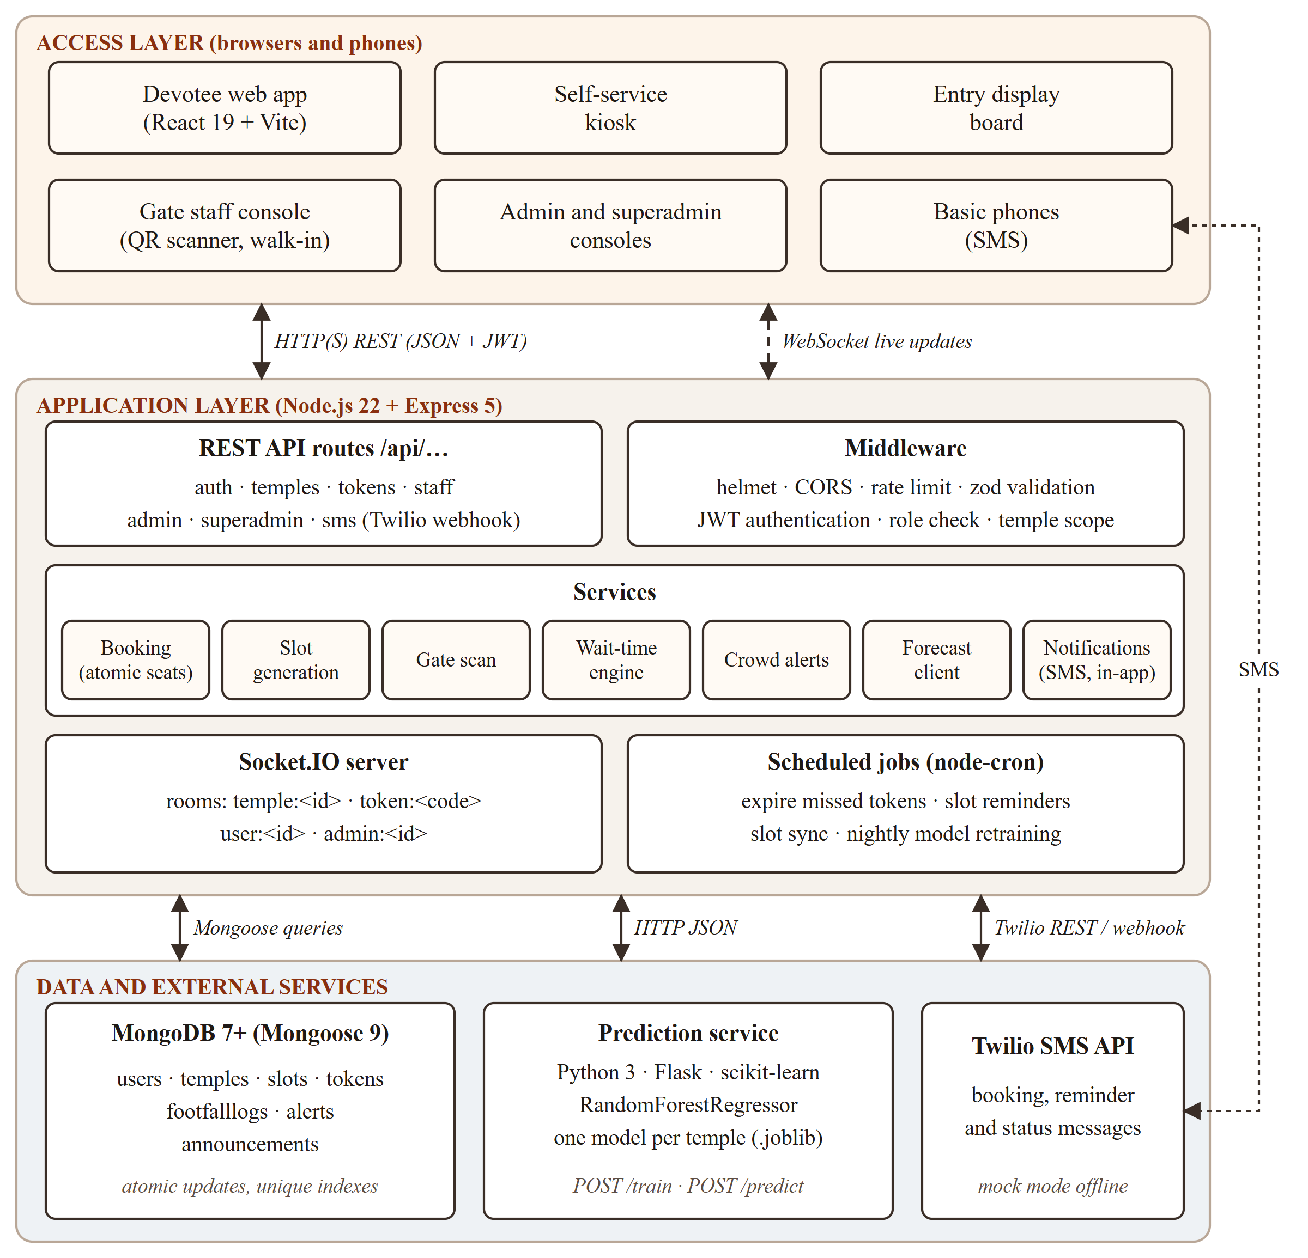
Fig 4.1: System architecture of Smart Darshan
- Access layer – every user interface is a page of one React single-page application that runs in any browser: the devotee website, the self-service kiosk, the entry display board, the gate staff console and the administrator and superadmin consoles. Devotees with basic phones interact through SMS.
- Application layer – a Node.js server built with Express 5 exposes a REST API under /api. Requests pass through a middleware chain – security headers and CORS on every request, rate limiting on login and registration, zod validation, and JWT authentication, role checks and temple scoping on protected routes – before reaching a controller, which calls the service layer that holds the business logic. A Socket.IO server pushes live updates, and scheduled jobs run maintenance tasks.
- Data and external services – MongoDB stores all data through Mongoose models. The prediction service is a separate Python Flask application that trains and serves one Random Forest model per temple. Twilio delivers outgoing SMS and forwards incoming SMS to the API webhook.
Clients send JSON over HTTP (HTTPS when deployed) with the session token in the Authorization header, and receive live updates over a WebSocket connection. The API calls the prediction service over HTTP with JSON bodies, so the two can be deployed and scaled independently.

4.2 MODULE DESCRIPTION
4.2.1 Authentication and user management
Handles registration, login, profile updates and password changes. Passwords are hashed with bcrypt and sessions use JSON Web Tokens. Four roles exist: devotee, gate staff, temple admin and superadmin. Staff and admins belong to exactly one temple, and the server always takes their temple from the account, never from the request, so one temple can never manage another.
4.2.2 Temple and slot management
Each temple has darshan types (lanes), opening hours, a festival calendar and crowd rules. Slots are generated automatically for the booking window from each darshan type’s slot length and capacity; festival days receive extra capacity, and every slot is split into an online quota and a walk-in quota.
4.2.3 Online booking module
Devotees choose a date, a darshan type and a time slot coloured by the predicted crowd, enter the group size and contact details, and receive a QR token. Group size, per-day booking limits and slot capacity are enforced on the server, and a booking can be cancelled until the slot starts, which releases its seats.
4.2.4 Walk-in counter and self-service kiosk
Gate staff issue walk-in tokens at the counter with a printable slip, and the kiosk lets devotees issue a token themselves in three taps. The earliest slot with free walk-in seats is chosen automatically, and unsold online seats become available to walk-ins in the hour before a slot starts.
4.2.5 Gate scanning module
Staff scan the QR code with the camera of a phone or laptop, or type the token code. An entry scan checks the temple, the token status, the entry window and whether entry is paused, and moves the token into the queue; an exit scan completes it. Every scan also updates the hourly footfall log used for prediction.
4.2.6 Live queue and wait-time engine
Computes, for every darshan lane, the number of people in the queue, the service rate measured at the exit gate and the estimated waiting time, and publishes the snapshot to every connected screen through Socket.IO.
4.2.7 Crowd alerts and entry control
Compares the queue with the temple’s safe limit and raises a warning at 90 % and a critical alert at 100 %. Administrators can pause entry at all gates with a reason that is shown to devotees, and the temple can optionally be configured to pause entry automatically at full capacity.
4.2.8 Prediction and analytics module
Trains a Random Forest model for each temple on hourly footfall, forecasts every hour of a day and recommends the three least crowded hours. The analytics page shows model accuracy, a seven-day forecast, actual versus predicted footfall, daily trends and a weekday-by-hour heatmap.
4.2.9 Notification module
Sends SMS for bookings, walk-in tokens, reminders before the slot and cancellations through Twilio, and answers inbound SMS commands: STATUS with a token code returns the queue position, WAIT with a temple name returns live waiting times and TEMPLES lists the temples. Logged-in users also receive in-app notifications.
4.2.10 Superadmin module
Lets the platform owner onboard a new temple together with its administrator account, activate or deactivate temples and monitor the queues of all temples from one screen.

4.3 DATABASE DESIGN
The data is stored in MongoDB in seven collections, shown with their relationships in Fig 4.2. Data that is always read together with its parent is embedded – darshan types, festivals, crowd settings and model metrics are part of the temple document – while data that grows without limit, such as slots, tokens and footfall logs, is kept in separate collections that reference the temple. Unique indexes guarantee that there is only one slot per temple, darshan type and start time, only one footfall record per temple, date and hour, and a unique code for every token.
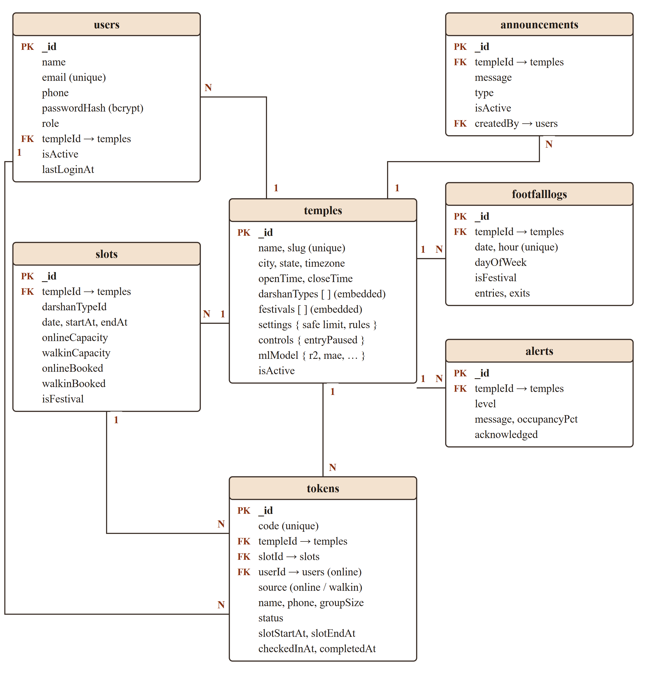
Fig 4.2: Database design (entity–relationship diagram)
Table 4.1: Database collections
Collection | Purpose
users | Devotee, staff, admin and superadmin accounts with role, temple and bcrypt password hash.
temples | Temple profile, timings, embedded darshan types and festivals, crowd settings, entry controls and model metrics.
slots | Time slots per temple and darshan type, with online and walk-in capacity and the seats booked from each.
tokens | Every online booking and walk-in token: code, group, status and the timestamps of entry and exit scans.
footfalllogs | Hourly entries and exits per temple – the history used to train the prediction model.
alerts | Occupancy alerts raised for administrators, with level and acknowledgement state.
announcements | Messages published by administrators to the temple page and display boards.

4.4 CLASS DIAGRAM
Fig 4.3 shows the classes of the system. Each Mongoose schema on the server is a class with typed attributes; the User class hashes and verifies passwords, and the Temple class answers whether a date is a festival and produces the public view of a temple. DarshanType is embedded in Temple (composition). ModelStore is the Python class in the prediction service that trains, saves, loads and serves one model per temple.
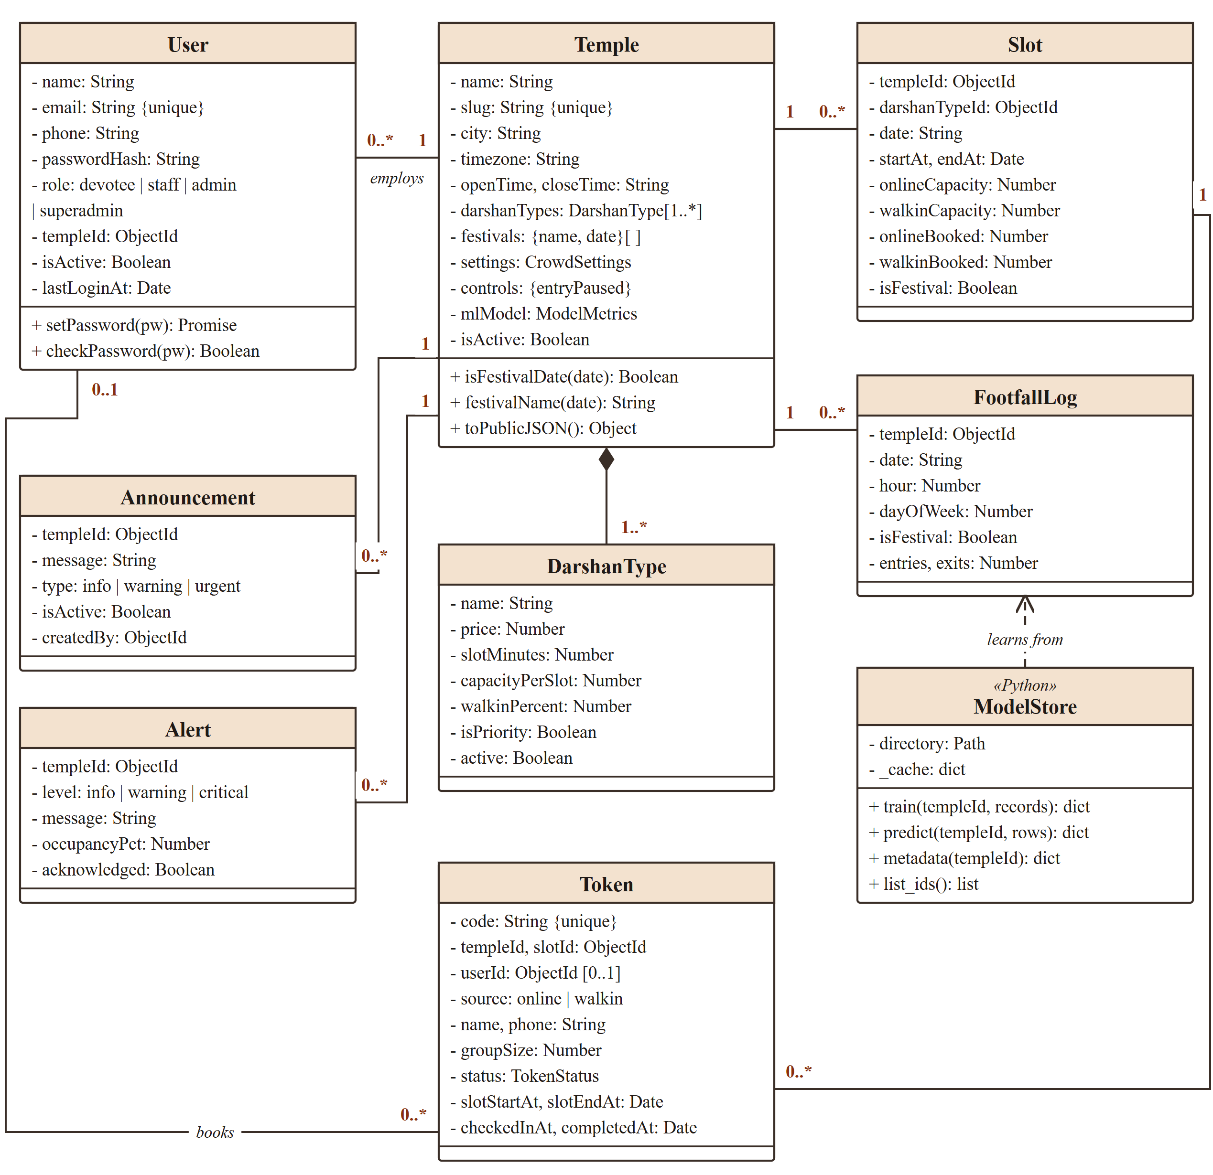
Fig 4.3: Class diagram

4.5 SEQUENCE DIAGRAM
Fig 4.4 shows the most important interaction of the system: a devotee books a slot online and later enters through the gate. The seat check and the seat increment happen in one database operation, so two devotees racing for the last seats can never overbook the slot. At the gate the scan moves the token into the queue and the new queue snapshot is pushed to the devotee’s phone immediately.
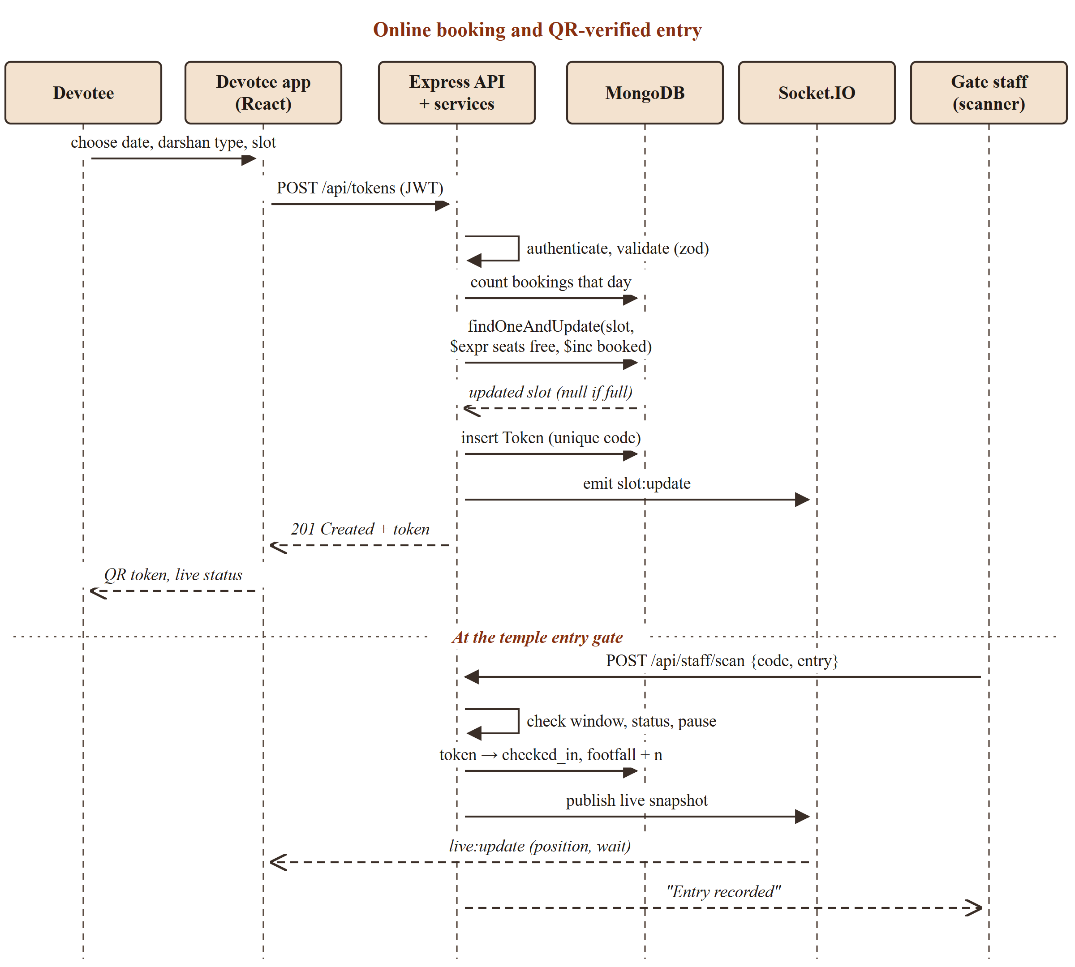
Fig 4.4: Sequence diagram – online booking and QR-verified entry
Fig 4.5 shows how a crowd forecast is produced. The forecast service first uses its ten-minute cache; otherwise it asks the Python prediction service for hourly predictions, falling back to historical weekday-hour averages if that service is offline. Every night at 02:30 the model is retrained on the latest footfall history and its metrics are stored with the temple.
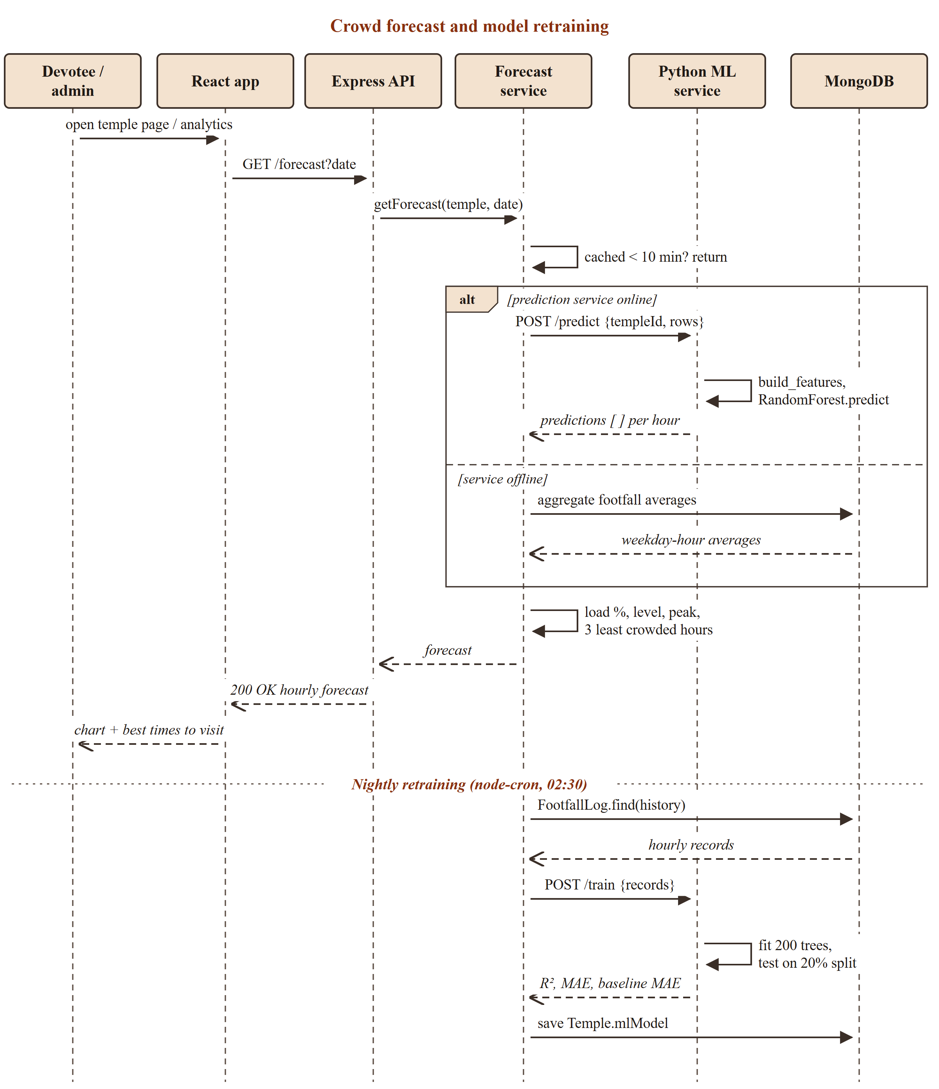
Fig 4.5: Sequence diagram – crowd forecast and model retraining

CHAPTER 5
IMPLEMENTATION

5.1 IMPLEMENTATION OVERVIEW
The project is organised as three applications in one repository (the full structure is given in the Appendix): client – the React 19 single-page application built with Vite and styled with Tailwind CSS; server – the Node.js API with Express 5, Mongoose and Socket.IO; and ml-service – the Python Flask prediction service. A single command, npm run dev, starts a local MongoDB server, the API on port 5000, the prediction service on port 8000 and the web application on port 5173.
A seed script creates three demonstration temples – in Hyderabad, Chennai and Bengaluru – each with three darshan types, their staff and administrator accounts, 25 devotee accounts, bookings for the current and next day, people already in the queue and 90 days of realistic hourly footfall with morning and evening peaks, weekend and festival surges. The models are trained immediately after seeding. A gate simulator issues walk-in tokens and scans devotees in and out through the real API, so dashboards, display boards and waiting times can be demonstrated live.
The main REST endpoints are listed in Table 5.1. Every request body and query is validated with zod schemas, and errors are returned in one consistent JSON format with an HTTP status code and a machine-readable error code.
Table 5.1: Main REST API endpoints
Method | Endpoint | Access | Purpose
POST | /api/auth/register, /api/auth/login | Public | Create an account / log in and receive a JWT
GET | /api/temples, /api/temples/:id | Public | Temples with live status; one temple
GET | /api/temples/:id/slots, /live, /forecast | Public | Slots with availability, live queue, hourly forecast
POST | /api/tokens | Devotee | Book a slot (create a token)
GET | /api/tokens/mine, /api/tokens/:code | Devotee / public | My bookings; live status of a token
POST | /api/tokens/:code/cancel | Owner / admin | Cancel a booking and release its seats
POST | /api/staff/walkin, /api/staff/scan | Staff | Issue walk-in token; entry or exit scan
PATCH | /api/admin/temple, /api/admin/controls | Admin | Update temple settings; pause or resume entry
GET | /api/admin/stats/today, /stats/trends | Admin | Dashboard statistics and crowd trends
POST | /api/admin/forecast/train | Admin | Retrain the temple’s prediction model
POST | /api/superadmin/temples | Superadmin | Onboard a temple with its admin account
POST | /api/sms/inbound | Twilio | Answer STATUS, WAIT and TEMPLES SMS commands

5.2 KEY FUNCTIONS (CODE EXPLANATION)
5.2.1 Automatic slot generation
buildSlotsForDate() converts the temple’s opening and closing time in its own time zone into UTC, then walks through the day in steps of each darshan type’s slot length. On a festival day the capacity is multiplied by the temple’s festival multiplier (1.5 by default), and every slot is split into a walk-in quota (walkinPercent) and an online quota. syncSlots() runs this for the seven-day booking window every hour; it creates missing slots, updates future slots without ever reducing capacity below what is already booked, and removes empty slots that no longer fit the timings.
server/src/services/slotService.js
export function buildSlotsForDate(temple, dateStr) {
const isFestival = temple.isFestivalDate(dateStr);
const multiplier = isFestival ? temple.settings.festivalCapacityMultiplier : 1;
const dayStart = zonedTimeToUtc(dateStr, temple.openTime, temple.timezone).getTime();
const dayEnd = zonedTimeToUtc(dateStr, temple.closeTime, temple.timezone).getTime();
const slots = [];

for (const dt of temple.darshanTypes.filter((d) => d.active)) {
const capacity = Math.round(dt.capacityPerSlot * multiplier);
const walkinCapacity = Math.round((capacity * dt.walkinPercent) / 100);
const step = dt.slotMinutes * MINUTE;

for (let t = dayStart; t + step <= dayEnd; t += step) {
slots.push({
templeId: temple._id,
darshanTypeId: dt._id,
date: dateStr,
startAt: new Date(t),
endAt: new Date(t + step),
onlineCapacity: capacity - walkinCapacity,
walkinCapacity,
isFestival,
});
}
}
return slots;
}
5.2.2 Atomic seat reservation
The most important correctness property of the system is that a slot can never be overbooked, even when many devotees book the last seats at the same moment. reserveSeats() achieves this without locks: the capacity check and the increment are a single findOneAndUpdate whose filter uses $expr, so MongoDB applies the update only if the seats are still free and returns null otherwise. Online bookings must also fit the online quota; walk-ins issued within the release window (60 minutes before the slot by default) may use any free seat, which is how unsold online seats reach walk-in devotees.
server/src/services/bookingService.js
function reserveSeats(slotId, groupSize, source, { useReleasedSeats = false } = {}) {
const counter = source === 'online' ? 'onlineBooked' : 'walkinBooked';
const quota = source === 'online' ? '$onlineCapacity' : '$walkinCapacity';
const conditions = [fitsTotal(groupSize)];
if (!useReleasedSeats) conditions.push({ $lte: [{ $add: [`$${counter}`, groupSize] }, quota] });

return Slot.findOneAndUpdate(
{ _id: slotId, $expr: { $and: conditions } },
{ $inc: { [counter]: groupSize } },
{ returnDocument: 'after' },
);
}
5.2.3 Gate scanning and the token lifecycle
Every token follows the life cycle shown in Fig 5.1. An entry scan is accepted only for a booked token of the same temple, within the entry window (from 15 minutes before the slot until 30 minutes after it ends) and while entry is not paused; the status change is again a conditional update, so a token scanned twice at the same moment is admitted only once. Scheduled jobs expire tokens whose slot was missed and complete tokens that were never scanned out.
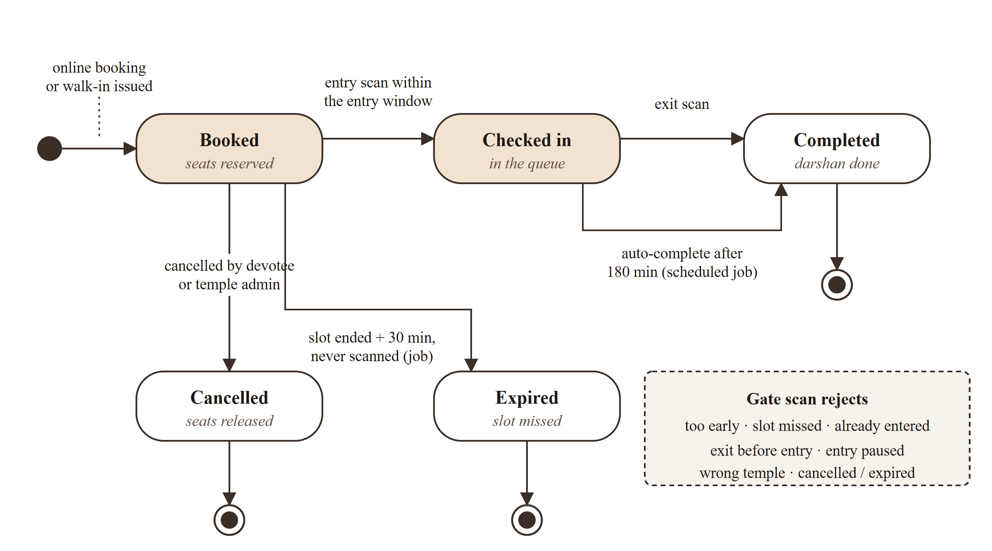
Fig 5.1: Token life cycle (state diagram)
server/src/services/scanService.js – entry scan
if (action === 'entry') {
if (temple.controls.entryPaused) {
fail(409, `Entry is paused${temple.controls.pauseReason ? `: ${temple.controls.pauseReason}` : ''}`, 'ENTRY_PAUSED');
}
if (token.status === 'checked_in') fail(409, `Already entered at ${formatTime(token.checkedInAt, tz)}`, 'ALREADY_ENTERED');
if (token.status === 'completed') fail(409, 'This darshan is already completed', 'ALREADY_COMPLETED');
if (STATUS_MESSAGES[token.status]) fail(409, STATUS_MESSAGES[token.status], 'TOKEN_INACTIVE');

const opensAt = new Date(token.slotStartAt.getTime() - temple.settings.checkinEarlyMin * MINUTE);
const closesAt = new Date(token.slotEndAt.getTime() + temple.settings.checkinLateMin * MINUTE);
if (now < opensAt) fail(409, `Too early. Entry opens at ${formatTime(opensAt, tz)}`, 'TOO_EARLY');
if (now > closesAt) fail(409, `Slot missed. Entry closed at ${formatTime(closesAt, tz)}`, 'SLOT_MISSED');

updated = await Token.findOneAndUpdate(
{ _id: token._id, status: 'booked' },
{ $set: { status: 'checked_in', checkedInAt: now, checkedInBy: staff._id } },
{ returnDocument: 'after' },
);
if (!updated) fail(409, 'This token was just scanned. Please scan again', 'CONFLICT');
await recordFootfall(temple, now, { entries: token.groupSize });
}
5.2.4 Wait-time engine
The waiting time is estimated with the relation between queue length, arrival rate and waiting time known as Little’s law [6]: the expected wait equals the number of people in the queue divided by the rate at which they are served. For each lane the engine counts the people checked in but not yet out, and measures the service rate as the number of people who exited in the last 15 minutes divided by the minutes actually observed. Until at least ten people have exited, the designed rate of the lane – capacity per slot divided by slot length – is used instead (Fig 5.2).
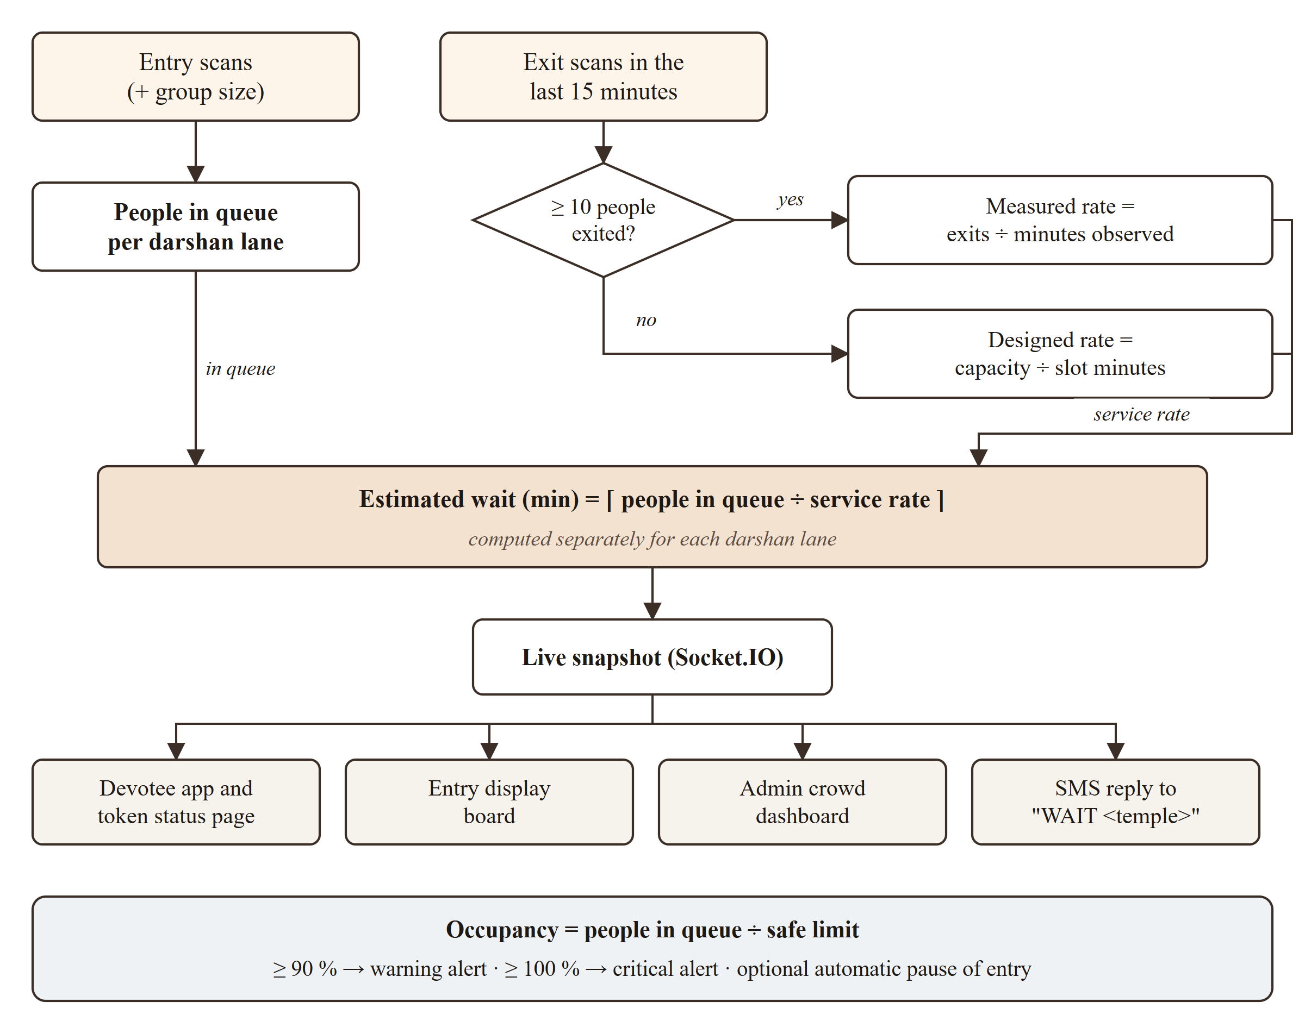
Fig 5.2: Wait-time engine
server/src/services/liveStats.js
const queue = byLane(queued, dt._id);
const done = byLane(recentlyCompleted, dt._id);
const inQueue = queue?.people ?? 0;
const completedRecently = done?.people ?? 0;
const measured = completedRecently >= MIN_MEASURED_PEOPLE;
// Measure over the span actually observed (at least 5 min), so a gate that only
// started exiting people a few minutes ago isn't treated as slow.
const observedMin = done
? Math.min(THROUGHPUT_WINDOW_MIN, Math.max(MIN_OBSERVED_MIN, (now.getTime() - new Date(done.firstAt).getTime()) / 60_000))
: THROUGHPUT_WINDOW_MIN;
const throughput = measured ? completedRecently / observedMin : defaultThroughput(dt);
const slot = currentSlots.find((s) => String(s.darshanTypeId) === String(dt._id));

return {
darshanTypeId: dt._id,
name: dt.name,
isPriority: dt.isPriority,
inQueue,
tokensInQueue: queue?.tokens ?? 0,
throughputPerMin: round1(throughput),
throughputSource: measured ? 'measured' : 'estimated',
waitMin: inQueue === 0 ? 0 : Math.ceil(inQueue / throughput),
5.2.5 Crowd alerts and automatic pause
After every snapshot, checkOccupancy() compares the queue with the safe limit. Only an escalation raises an alert, so administrators are not flooded with repeated messages; the alert is saved and pushed to the admin room immediately, and at 100 % the temple can pause entry on its own if that option is enabled.
server/src/services/alertService.js
export async function checkOccupancy(temple, snapshot) {
const key = String(temple._id);
const pct = snapshot.totals.occupancyPct;
const level = pct >= 100 ? 'critical' : pct >= 90 ? 'warning' : 'normal';
const previous = lastLevels.get(key) ?? 'normal';
lastLevels.set(key, level);

if (SEVERITY[level] <= SEVERITY[previous]) return;

const { inQueue, maxOccupancy } = snapshot.totals;
await raiseAlert(temple._id, {
level,
occupancyPct: pct,
message:
level === 'critical'
? `Queue is at full capacity: ${inQueue} people waiting (limit ${maxOccupancy}).`
: `Queue is nearing capacity: ${inQueue} of ${maxOccupancy} (${pct}%).`,
});

if (level === 'critical' && temple.settings.autoPauseAtCapacity && !temple.controls.entryPaused) {
await Temple.updateOne(
{ _id: temple._id },
{
$set: {
'controls.entryPaused': true,
'controls.pauseReason': 'Queue at full capacity. Entry will resume shortly.',
'controls.pausedAt': new Date(),
},
},
);
await raiseAlert(temple._id, { level: 'info', message: 'Entry was paused automatically. Resume it from the dashboard.' });
const { schedulePublish } = await import('./liveStats.js');
schedulePublish(temple._id);
}
}
5.2.6 Crowd prediction
Every entry and exit scan increments the hourly footfall log of the temple, which becomes the training data of the prediction module (Fig 5.3). The features are the hour of the day, the day of the week, the month, a weekend flag, a festival flag and a sine–cosine encoding of the hour, so that 11 pm and midnight are treated as neighbours. A Random Forest regressor [7] of 200 trees (maximum depth 14) from scikit-learn [8] is trained for each temple on 80 % of the history and evaluated on the remaining 20 %, then refitted on all the data and saved.
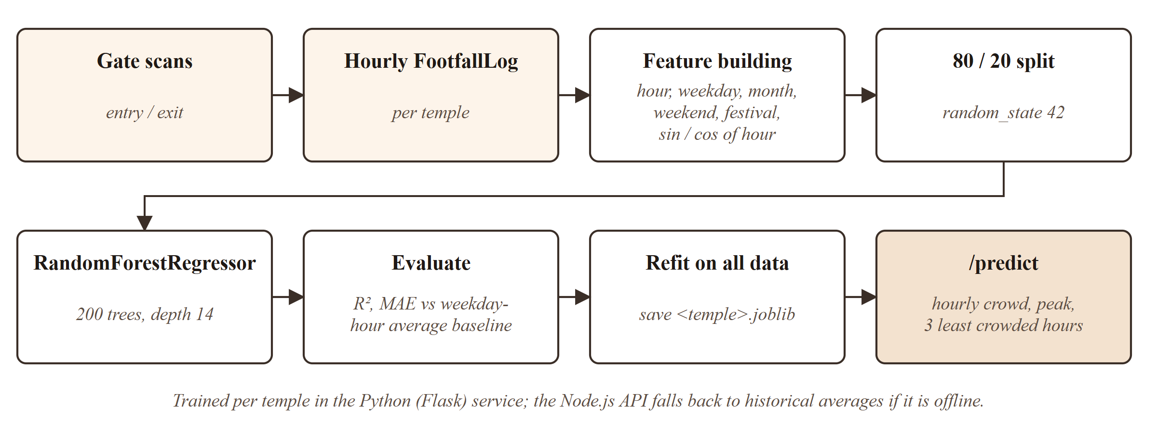
Fig 5.3: Crowd prediction pipeline
ml-service/model.py – feature building
def build_features(rows: list[dict]) -> pd.DataFrame:
"""Turns raw rows ({hour, dayOfWeek, month, isFestival}) into model features."""
df = pd.DataFrame(rows)
missing = {"hour", "dayOfWeek", "month", "isFestival"} - set(df.columns)
if missing:
raise ModelError(f"Missing fields: {', '.join(sorted(missing))}")

features = pd.DataFrame(
{
"hour": df["hour"].astype(int),
"day_of_week": df["dayOfWeek"].astype(int),
"month": df["month"].astype(int),
"is_weekend": df["dayOfWeek"].isin([0, 6]).astype(int),
"is_festival": df["isFestival"].astype(int),
}
)
# Cyclical encoding so hour 23 and hour 0 are treated as neighbours.
features["hour_sin"] = np.sin(2 * np.pi * features["hour"] / 24)
features["hour_cos"] = np.cos(2 * np.pi * features["hour"] / 24)
return features[FEATURES]
ml-service/model.py – training and evaluation
train_df, test_df = train_test_split(frame, test_size=0.2, random_state=42)
model = RandomForestRegressor(
n_estimators=200, max_depth=14, min_samples_leaf=2, random_state=42, n_jobs=-1
)
model.fit(train_df[FEATURES], train_df["entries"])
predictions = model.predict(test_df[FEATURES])

mae = float(mean_absolute_error(test_df["entries"], predictions))
r2 = float(r2_score(test_df["entries"], predictions))
baseline_mae = seasonal_baseline_mae(train_df, test_df)
When the Node.js API needs a forecast it sends every open hour of the requested day (16 to 17 hours for the demonstration temples) to /predict, converts the predicted visitors per hour into a load percentage of the temple’s hourly capacity and a crowd level, and selects the peak hour and the three least crowded remaining hours. If the prediction service is unreachable, the API uses the historical average for the same weekday, hour and festival flag, so devotees always see a forecast.
5.2.7 Authentication and temple scoping
Login returns a JSON Web Token [9] signed with the server’s secret and valid for seven days; passwords are compared with bcrypt [10]. Every protected route runs authenticate(), which verifies the token and loads the active user, and requireRole(), which checks the role. Staff and admin routes also run templeScope(), which takes the temple from the user’s account – only a superadmin may choose a temple, through the X-Temple-Id header – so a staff member of one temple can never act on another.
server/src/middleware/templeScope.js
export async function templeScope(req, _res, next) {
const isSuper = req.user.role === 'superadmin';
const templeId = isSuper ? req.get('X-Temple-Id') : req.user.templeId;

if (!templeId) {
throw new AppError(400, isSuper ? 'Select a temple to manage first' : 'Your account is not linked to a temple', 'TEMPLE_REQUIRED');
}
if (!isObjectId(templeId)) throw new AppError(400, 'Invalid temple id');

const temple = await Temple.findById(templeId);
if (!temple) throw new AppError(404, 'Temple not found');
if (!temple.isActive && !isSuper) throw new AppError(403, 'This temple is currently inactive');

req.temple = temple;
next();
}
5.2.8 Real-time updates with Socket.IO
Clients join rooms instead of polling. temple:<id> receives queue snapshots and announcements, token:<code> receives status changes of one token, user:<id> receives personal notifications and admin:<id> receives crowd alerts; only that temple’s staff, its admins and the superadmin may join an admin room.
server/src/sockets/index.js
function roomFor(type, id, user) {
if (type === 'temple' && isObjectId(id)) return `temple:${id}`;
if (type === 'token' && TOKEN_CODE_REGEX.test(String(id))) return `token:${id}`;
if (type === 'admin' && isObjectId(id) && user) {
const allowed = user.role === 'superadmin' || (['admin', 'staff'].includes(user.role) && user.templeId === id);
if (allowed) return `admin:${id}`;
}
return null;
}

5.3 TESTING AND RESULTS
5.3.1 Automated API testing
An end-to-end test script exercises the running API exactly as the web application does. It contains 49 checks, summarised in Table 5.2, and all 49 pass.
Table 5.2: Automated end-to-end test coverage
Area | What is verified
Public pages | Temple list and detail, slots for today, live snapshot, ML forecast, rejection of out-of-range dates
Accounts | Registration, duplicate e-mail rejected, wrong password rejected, devotee and staff login
Online booking | Booking, group-size limit, my tokens, masked name on the public status page, booking for tomorrow, cancellation and seat release
Walk-ins and gate scans | Walk-in slots and token issue, entry by token code and by QR link, exit before entry rejected, double entry rejected, queue position, exit
Administration | Today’s statistics, 30-day trends, 7-day forecast, model status, pause entry and scan rejected while paused, resume, announcements, slots, staff list, idempotent slot sync, settings update, alerts
Access control | Staff blocked from admin routes, admin cannot switch temple with the header, superadmin must select a temple, superadmin scoped access
SMS | STATUS reply for a token and WAIT reply for a temple

5.3.2 Prediction accuracy
Table 5.3 and Fig 5.4 report the accuracy of the model for each demonstration temple on its held-out 20 % test set. The baseline is a simple but strong guess: the average footfall of the same weekday, hour and festival flag in the training data. The model explains 90 to 94 % of the variance in hourly footfall (R²) and reduces the mean absolute error by 15 to 26 % compared with the baseline.
Table 5.3: Prediction model results (test set)
Temple | Training records | R² | MAE (visitors / hour) | Baseline MAE | Error reduction
Sri Venkateswara Swamy Temple | 1440 (288 test) | 0.9015 | 39.79 | 50.21 | 20.8 %
Arulmigu Murugan Temple | 1350 (270 test) | 0.9167 | 19.88 | 23.49 | 15.4 %
Sri Mahalakshmi Temple | 1530 (306 test) | 0.9364 | 13.04 | 17.52 | 25.6 %

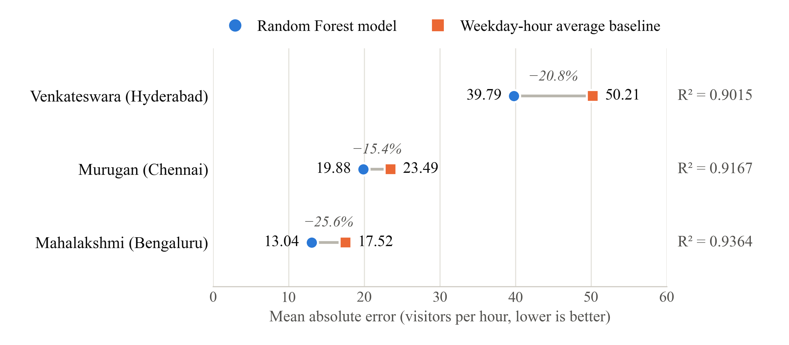
Fig 5.4: Prediction error of the model compared with the baseline
5.3.3 Live demonstration
With the gate simulator running against the Hyderabad demonstration temple, the queue grew to more than six hundred people across the three lanes. Queue counts and waiting times on the token page, the display board and the dashboard changed live as the simulated scans arrived, and with the safe limit set to 710 people the dashboard raised the warning alert “Queue is nearing capacity: 656 of 710 (92%)” automatically (Fig S.15). The screenshots of the project are presented after the Appendix.

CHAPTER 6
CONCLUSION & FUTURE WORK

6.1 CONCLUSION
Smart Darshan shows that the long, uncertain waiting of devotees can be addressed entirely in software. Replacing the physical line with a slot-based virtual queue spreads arrivals across the day, and a single QR scan at the entry and exit gates is enough to know at every moment how many people are in each queue and how fast it is moving. From these two numbers the system gives every devotee a live position and waiting time, on the web, on display boards and by SMS.
The project met its objectives. Online bookings and walk-ins share one capacity model in which seats are reserved atomically, so slots cannot be overbooked. The wait-time engine pushes a new queue snapshot to every connected screen as soon as a scan is recorded. Administrators receive occupancy alerts at 90 % and 100 % of the safe limit and can pause entry at all gates instantly. The prediction module forecasts hourly crowds with an R² of 0.90 to 0.94 and recommends the least crowded hours. The platform supports any number of temples with strict role-based access, and its behaviour is verified by 49 automated end-to-end checks.

6.2 FUTURE ENHANCEMENTS
- Online payment for paid darshan types through a payment gateway, with automatic refunds on cancellation.
- Installable mobile app (progressive web app) with push notifications as the queue moves and when entry opens.
- Multilingual interface in Tamil, Telugu, Kannada and Hindi, and voice announcements on display boards.
- Dynamic capacity that adjusts slot sizes automatically from the forecast and the live service rate.
- WhatsApp notifications in addition to SMS, and signed QR codes that can be verified even without network access at the gate.
- Optional camera-based counting to cross-check gate scans in very large temples, using the density estimation approaches reviewed in Chapter 2.
- Cloud deployment on MongoDB Atlas and a managed Node.js host, with load testing for festival-scale traffic.

APPENDIX
SOURCE CODE:
1. Project Structure
Project folder structure of Smart Darshan:
smart-darshan/
├── client/ – React 19 + Vite + Tailwind CSS
│ ├── index.html
│ ├── vite.config.js
│ └── src/
│ ├── App.jsx – routes
│ ├── main.jsx
│ ├── components/ – CrowdMeter, LiveLanes, QrScanner, charts/, layout/, …
│ ├── context/ – AuthContext.jsx, SocketContext.jsx
│ ├── hooks/ – useFetch.js, useLiveTemple.js
│ ├── lib/ – api.js, constants.js, format.js
│ └── pages/
│ ├── public/ – Home, TempleDetail, TokenStatus, DisplayBoard, …
│ ├── auth/ – Login, Register
│ ├── devotee/ – BookDarshan, MyTokens, Profile
│ ├── staff/ – Scanner, WalkinCounter, Kiosk
│ ├── admin/ – Dashboard, Analytics, Slots, Announcements, Staff, Settings
│ └── super/ – SuperTemples
├── server/ – Node.js + Express 5 + Socket.IO
│ ├── .env.example
│ ├── package.json
│ ├── tests/api.test.mjs – 49 end-to-end checks
│ └── src/
│ ├── server.js – entry point
│ ├── app.js – Express app and middleware
│ ├── config/ – db.js, env.js
│ ├── controllers/ – auth, temple, token, staff, admin, superadmin, sms
│ ├── middleware/ – auth.js, templeScope.js, validate.js, errorHandler.js
│ ├── models/ – User, Temple, Slot, Token, FootfallLog, Alert, Announcement
│ ├── routes/ – index.js, authRoutes.js, templeRoutes.js, tokenRoutes.js, …
│ ├── services/ – booking, slot, scan, liveStats, alert, forecast, sms, …
│ ├── sockets/index.js – Socket.IO rooms
│ ├── jobs/index.js – scheduled jobs (node-cron)
│ └── scripts/ – seed.js, backfill.js, simulate.js, localDb.js
├── ml-service/ – Python Flask prediction service
│ ├── app.py
│ ├── model.py
│ └── requirements.txt
├── package.json – npm run setup | dev | seed | test:api
└── README.md
2. Backend Package Installation
# Backend (server/)
cd server
npm install express mongoose socket.io jsonwebtoken bcryptjs zod cors helmet morgan express-rate-limit node-cron dotenv twilio
npm install --save-dev mongodb-memory-server

# Frontend (client/)
cd ../client
npm install react react-dom react-router-dom axios socket.io-client recharts html5-qrcode qrcode.react lucide-react react-hot-toast
npm install --save-dev vite @vitejs/plugin-react tailwindcss @tailwindcss/vite

# Prediction service (ml-service/)
cd ..
python -m pip install -r ml-service/requirements.txt

# Run everything from the project root
npm run setup # installs all of the above
npm run seed # demo temples, accounts and 90 days of footfall; trains the models
npm run dev # MongoDB + API (port 5000) + ML service (port 8000) + web app (port 5173)
3. Database Connection
server/src/config/db.js
import mongoose from 'mongoose';
import env from './env.js';

const RETRY_DELAY_MS = 3000;
const MAX_ATTEMPTS = 40;

/**
* Connects to MongoDB, retrying for a while so the API can start before the
* database is ready (e.g. when `npm run dev` launches both together).
*/
export async function connectDB(uri = env.mongoUri) {
mongoose.set('strictQuery', true);

for (let attempt = 1; attempt <= MAX_ATTEMPTS; attempt += 1) {
try {
await mongoose.connect(uri, { serverSelectionTimeoutMS: 5000 });
console.log(`[db] connected to ${redact(uri)}`);
return mongoose.connection;
} catch (err) {
if (attempt === MAX_ATTEMPTS) throw err;
console.log(`[db] waiting for MongoDB (${attempt}/${MAX_ATTEMPTS}): ${err.message}`);
await new Promise((resolve) => setTimeout(resolve, RETRY_DELAY_MS));
}
}
return mongoose.connection;
}

export function disconnectDB() {
return mongoose.disconnect();
}

function redact(uri) {
return uri.replace(/\/\/([^:]+):([^@]+)@/, '//$1:****@');
}
4. Environment Variables
The real values are kept in server/.env, which is excluded from version control; the template below is committed instead.
server/.env.example
# Copy this file to .env and adjust.

PORT=5000
NODE_ENV=development

# Local dev: `npm run db` starts MongoDB on this address (no install needed).
# MongoDB Atlas: mongodb+srv://<user>:<password>@<cluster>.mongodb.net/smart_darshan
MONGO_URI=mongodb://127.0.0.1:27017/smart_darshan

# Use a long random string in production.
JWT_SECRET=change-this-to-a-long-random-string
JWT_EXPIRES_IN=7d

# Frontend URL(s), comma-separated. Used for CORS and links in SMS messages.
CLIENT_URL=http://localhost:5173

# Python prediction service (ml-service/).
ML_SERVICE_URL=http://127.0.0.1:8000

# Load demo data automatically when the database is empty.
AUTO_SEED=true

# Twilio SMS (optional). Leave blank to log SMS messages to the console instead.
DEFAULT_COUNTRY_CODE=+91
TWILIO_ACCOUNT_SID=
TWILIO_AUTH_TOKEN=
TWILIO_FROM_NUMBER=
# Public URL of POST /api/sms/inbound; when set, Twilio signatures are verified.
TWILIO_WEBHOOK_URL=
5. User Model
server/src/models/User.js
import bcrypt from 'bcryptjs';
import mongoose from 'mongoose';

export const ROLES = ['devotee', 'staff', 'admin', 'superadmin'];

const userSchema = new mongoose.Schema(
{
name: { type: String, required: true, trim: true, maxlength: 80 },
email: { type: String, required: true, unique: true, lowercase: true, trim: true },
phone: { type: String, trim: true },
passwordHash: { type: String, required: true, select: false },
role: { type: String, enum: ROLES, default: 'devotee' },
// Staff and temple admins belong to exactly one temple.
templeId: { type: mongoose.Schema.Types.ObjectId, ref: 'Temple' },
isActive: { type: Boolean, default: true },
lastLoginAt: Date,
},
{
timestamps: true,
toJSON: {
transform(_doc, ret) {
delete ret.passwordHash;
delete ret.__v;
return ret;
},
},
},
);

userSchema.methods.setPassword = async function setPassword(password) {
this.passwordHash = await bcrypt.hash(password, 10);
};

userSchema.methods.checkPassword = function checkPassword(password) {
return bcrypt.compare(password, this.passwordHash);
};

export default mongoose.model('User', userSchema);
6. Password Hashing and Registration
The password rule is validated with zod before the controller runs; User.setPassword() (above) hashes it with bcrypt at cost factor 10.
server/src/routes/schemas.js
export const email = z.string().trim().toLowerCase().email('Enter a valid email');
export const password = z.string().min(6, 'Password must be at least 6 characters').max(100);
server/src/controllers/authController.js
export async function register(req, res) {
const { name, email, phone, password } = req.valid.body;
if (await User.exists({ email })) throw new AppError(409, 'An account with this email already exists', 'EMAIL_TAKEN');

const user = new User({ name, email, phone: normalizePhone(phone) || undefined, role: 'devotee' });
await user.setPassword(password);
await user.save();

res.status(201).json({ token: signToken(user), user });
}
7. Login and JWT Generation
server/src/middleware/auth.js
export function signToken(user) {
return jwt.sign({ sub: String(user._id), role: user.role }, env.jwtSecret, { expiresIn: env.jwtExpiresIn });
}
server/src/controllers/authController.js
export async function login(req, res) {
const { email, password } = req.valid.body;
const user = await User.findOne({ email }).select('+passwordHash');
if (!user || !(await user.checkPassword(password))) {
throw new AppError(401, 'Incorrect email or password', 'BAD_CREDENTIALS');
}
if (!user.isActive) throw new AppError(403, 'This account has been deactivated', 'ACCOUNT_DISABLED');

user.lastLoginAt = new Date();
await user.save();
res.json({ token: signToken(user), user });
}
8. Authentication Middleware
server/src/middleware/auth.js
export async function userFromJwt(token) {
let payload;
try {
payload = jwt.verify(token, env.jwtSecret);
} catch {
return null;
}
const user = await User.findById(payload.sub);
return user?.isActive ? user : null;
}

function bearerToken(req) {
const header = req.get('Authorization') || '';
return header.startsWith('Bearer ') ? header.slice(7) : null;
}

export async function authenticate(req, _res, next) {
const token = bearerToken(req);
if (!token) throw new AppError(401, 'Please log in to continue', 'AUTH_REQUIRED');
const user = await userFromJwt(token);
if (!user) throw new AppError(401, 'Your session has expired. Please log in again', 'AUTH_INVALID');
req.user = user;
next();
}

/** Attaches req.user when a valid token is sent, but never rejects the request. */
export async function optionalAuth(req, _res, next) {
const token = bearerToken(req);
if (token) req.user = await userFromJwt(token);
next();
}

export function requireRole(...roles) {
return (req, _res, next) => {
if (!req.user || !roles.includes(req.user.role)) {
throw new AppError(403, 'You do not have permission to do this', 'FORBIDDEN');
}
next();
};
}
9. Create API
POST /api/tokens creates an online booking (a token). The route validates the body, the controller calls the booking service, and the service enforces the limits and reserves the seats atomically.
server/src/routes/tokenRoutes.js
router.post(
'/',
authenticate,
requireRole('devotee'),
validate({ body: z.object({ slotId: objectId, groupSize, name: personName, phone: optionalPhone }) }),
tokens.bookOnline,
);
server/src/controllers/tokenController.js
export async function bookOnline(req, res) {
const { token, temple } = await createOnlineBooking(req.user, req.valid.body);
res.status(201).json({ token: serializeToken(token, temple, { full: true }) });
}
server/src/services/bookingService.js
export async function createOnlineBooking(user, { slotId, groupSize, name, phone }, { silent = false } = {}) {
const slot = await Slot.findById(slotId);
if (!slot) throw new AppError(404, 'Slot not found');

const temple = await Temple.findById(slot.templeId);
if (!temple?.isActive) throw new AppError(404, 'Temple not found');

const darshanType = temple.darshanTypes.id(slot.darshanTypeId);
if (!darshanType?.active) throw new AppError(400, 'This darshan type is no longer available');

if (groupSize > temple.settings.maxGroupSize) {
throw new AppError(400, `A booking can include at most ${temple.settings.maxGroupSize} people`);
}
if (slot.endAt.getTime() - Date.now() < ONLINE_BOOKING_CUTOFF_MIN * MINUTE) {
throw new AppError(400, 'This slot is no longer open for booking', 'SLOT_CLOSED');
}

const bookingsThatDay = await Token.countDocuments({
userId: user._id,
templeId: temple._id,
slotDate: slot.date,
status: { $in: ACTIVE_STATUSES },
});
if (bookingsThatDay >= temple.settings.maxBookingsPerUserPerDay) {
throw new AppError(
400,
`You can make at most ${temple.settings.maxBookingsPerUserPerDay} bookings per day at this temple`,
'BOOKING_LIMIT',
);
}

const reserved = await reserveSeats(slot._id, groupSize, 'online');
if (!reserved) throw new AppError(409, 'Sorry, not enough seats are left in this slot', 'SLOT_FULL');

let token;
try {
token = await createTokenDoc(tokenData({ slot, temple, darshanType, groupSize, name, phone, userId: user._id, source: 'online' }));
} catch (err) {
await releaseSeats(slot._id, groupSize, 'online');
throw err;
}

emitSlotChanged(reserved, temple);
if (!silent) {
notifyTokenHolder(token, {
title: 'Darshan booked',
message: `Token ${token.code} confirmed for ${darshanType.name} at ${temple.name}, ${describeSlot(token, temple)} (${groupSize} ${groupSize === 1 ? 'person' : 'people'}). Track: ${tokenLink(token.code)}`,
sms: true,
level: 'success',
});
}
return { token, temple };
}
10. Read API
GET /api/temples lists active temples with their live status, and GET /api/tokens/mine returns the logged-in devotee’s bookings.
server/src/controllers/templeController.js
export async function listTemples(req, res) {
const { q, city } = req.valid.query;
const filter = { isActive: true };
if (q) {
const pattern = new RegExp(escapeRegex(q), 'i');
filter.$or = [{ name: pattern }, { city: pattern }, { deity: pattern }, { state: pattern }];
}
if (city) filter.city = new RegExp(`^${escapeRegex(city)}$`, 'i');

const temples = await Temple.find(filter).sort({ name: 1 });
const withLive = await Promise.all(
temples.map(async (temple) => {
const live = await getSnapshot(temple._id, { maxAgeMs: 30_000 }).catch(() => null);
return {
...temple.toPublicJSON(),
live: live && {
isOpen: live.isOpen,
entryPaused: live.entryPaused,
inQueue: live.totals.inQueue,
generalWaitMin: live.totals.generalWaitMin,
occupancyPct: live.totals.occupancyPct,
festival: live.festival,
},
};
}),
);
const cities = await Temple.distinct('city', { isActive: true });
res.json({ temples: withLive, cities: cities.sort() });
}
server/src/controllers/tokenController.js
export async function myTokens(req, res) {
const { scope } = req.valid.query;
const now = new Date();
const filter = { userId: req.user._id };
if (scope === 'upcoming') filter.status = { $in: ['booked', 'checked_in'] };
if (scope === 'past') filter.status = { $in: ['completed', 'cancelled', 'expired'] };

const tokens = await Token.find(filter)
.sort({ slotStartAt: scope === 'past' ? -1 : 1 })
.limit(100);
const temples = await Temple.find({ _id: { $in: [...new Set(tokens.map((t) => String(t.templeId)))] } });
const templeById = new Map(temples.map((t) => [String(t._id), t]));

res.json({
now,
tokens: tokens
.filter((t) => templeById.has(String(t.templeId)))
.map((t) => serializeToken(t, templeById.get(String(t.templeId)), { full: true })),
});
}
11. Update
PATCH /api/admin/temple updates the temple profile, timings, crowd settings and festivals, and re-synchronises the slots when they are affected.
server/src/controllers/adminController.js
export async function updateTemple(req, res) {
const { temple } = req;
const { settings, festivals, ...profile } = req.valid.body;

Object.assign(temple, profile);
if (settings) Object.assign(temple.settings, settings);
if (festivals) temple.festivals = festivals;
await temple.save();

const timingsChanged = ['openTime', 'closeTime', 'timezone'].some((f) => f in profile);
const slotResult = timingsChanged || festivals || settings ? await syncSlots(temple) : null;
clearForecastCache(temple._id);
schedulePublish(temple._id);
res.json({ temple, slotSync: slotResult });
}
12. Delete
Bookings are never physically deleted, so that the history used for analytics stays complete. Deleting a booking is a cancellation: POST /api/tokens/:code/cancel marks the token as cancelled with a conditional update and returns its seats to the slot.
server/src/controllers/tokenController.js
export async function cancel(req, res) {
const token = await findTokenByCode(req.params.code);
const cancelled = await cancelToken(req.user, token);
const temple = await Temple.findById(cancelled.templeId);
res.json({ token: serializeToken(cancelled, temple, { full: true }) });
}
server/src/services/bookingService.js
export async function cancelToken(user, token) {
const isOwner = token.userId && String(token.userId) === String(user._id);
const isTempleManager = user.role === 'superadmin' || (user.role === 'admin' && String(user.templeId) === String(token.templeId));
if (!isOwner && !isTempleManager) throw new AppError(403, 'You can only cancel your own bookings');

if (token.status !== 'booked') throw new AppError(409, `A ${token.status.replace('_', ' ')} token cannot be cancelled`);
if (token.slotStartAt <= new Date() && !isTempleManager) {
throw new AppError(409, 'This slot has already started and can no longer be cancelled');
}

const cancelled = await Token.findOneAndUpdate(
{ _id: token._id, status: 'booked' },
{ $set: { status: 'cancelled', cancelledAt: new Date() } },
{ returnDocument: 'after' },
);
if (!cancelled) throw new AppError(409, 'This token was updated by someone else. Please refresh');

await releaseSeats(token.slotId, token.groupSize, token.source);

const temple = await Temple.findById(token.templeId);
const slot = await Slot.findById(token.slotId);
if (slot && temple) emitSlotChanged(slot, temple);
emitTokenChanged(cancelled);
notifyTokenHolder(cancelled, {
title: 'Booking cancelled',
message: `Token ${cancelled.code} at ${temple?.name ?? 'the temple'} has been cancelled.`,
sms: true,
});
return cancelled;
}
13. Express Routes
server/src/routes/index.js
import express, { Router } from 'express';
import mongoose from 'mongoose';
import env from '../config/env.js';
import { inboundSms } from '../controllers/smsController.js';
import { mlHealth } from '../services/mlClient.js';
import adminRoutes from './adminRoutes.js';
import authRoutes from './authRoutes.js';
import staffRoutes from './staffRoutes.js';
import superadminRoutes from './superadminRoutes.js';
import templeRoutes from './templeRoutes.js';
import tokenRoutes from './tokenRoutes.js';

const router = Router();

router.get('/health', async (_req, res) => {
res.json({
ok: true,
db: mongoose.connection.readyState === 1 ? 'connected' : 'disconnected',
ml: await mlHealth(),
sms: env.smsEnabled ? 'twilio' : 'mock',
time: new Date(),
});
});

router.use('/auth', authRoutes);
router.use('/temples', templeRoutes);
router.use('/tokens', tokenRoutes);
router.use('/staff', staffRoutes);
router.use('/admin', adminRoutes);
router.use('/superadmin', superadminRoutes);
router.post('/sms/inbound', express.urlencoded({ extended: false }), inboundSms);

export default router;
server/src/routes/authRoutes.js
import { Router } from 'express';
import rateLimit from 'express-rate-limit';
import { z } from 'zod';
import * as auth from '../controllers/authController.js';
import { authenticate } from '../middleware/auth.js';
import { validate } from '../middleware/validate.js';
import { email, optionalPhone, password, personName } from './schemas.js';

const router = Router();

const authLimiter = rateLimit({
windowMs: 15 * 60_000,
limit: 50,
standardHeaders: 'draft-8',
legacyHeaders: false,
message: { error: { message: 'Too many attempts. Please try again in a few minutes.', code: 'RATE_LIMITED' } },
});

router.post(
'/register',
authLimiter,
validate({ body: z.object({ name: personName, email, phone: optionalPhone, password }) }),
auth.register,
);
router.post('/login', authLimiter, validate({ body: z.object({ email, password: z.string().min(1) }) }), auth.login);
router.get('/me', authenticate, auth.me);
router.patch('/me', authenticate, validate({ body: z.object({ name: personName.optional(), phone: optionalPhone }) }), auth.updateMe);
router.post(
'/me/password',
authenticate,
validate({ body: z.object({ currentPassword: z.string().min(1), newPassword: password }) }),
auth.changePassword,
);

export default router;
14. Main Server File
server/src/server.js
import http from 'node:http';
import { createApp } from './app.js';
import { connectDB, disconnectDB } from './config/db.js';
import env from './config/env.js';
import { startJobs } from './jobs/index.js';
import Temple from './models/Temple.js';
import { seedDatabase } from './scripts/seedData.js';
import { getSnapshot } from './services/liveStats.js';
import { initSocket } from './sockets/index.js';

async function main() {
await connectDB();

if (env.autoSeed && !(await Temple.exists({}))) {
console.log('[seed] empty database detected, loading demo data...');
await seedDatabase();
}

const app = createApp();
const server = http.createServer(app);
initSocket(server, { getSnapshot });

server.listen(env.port, () => {
console.log(`[api] Smart Darshan API running on http://localhost:${env.port}`);
console.log(`[api] SMS mode: ${env.smsEnabled ? 'Twilio' : 'mock (messages are logged here)'}`);
});

startJobs();

const shutdown = async (signal) => {
console.log(`[api] ${signal} received, shutting down`);
server.close();
await disconnectDB();
process.exit(0);
};
process.on('SIGINT', shutdown);
process.on('SIGTERM', shutdown);
}

main().catch((err) => {
console.error('[api] failed to start:', err);
process.exit(1);
});
server/src/app.js
import cors from 'cors';
import express from 'express';
import helmet from 'helmet';
import morgan from 'morgan';
import env from './config/env.js';
import { errorHandler, notFound } from './middleware/errorHandler.js';
import apiRoutes from './routes/index.js';

export function createApp() {
const app = express();

app.set('trust proxy', 1);
app.use(helmet());
app.use(cors({ origin: env.clientUrls, credentials: true }));
app.use(express.json({ limit: '1mb' }));
if (!env.isProduction) app.use(morgan('dev', { skip: (req) => req.path === '/api/health' }));

app.get('/', (_req, res) => res.json({ name: 'Smart Darshan API', docs: '/api/health' }));
app.use('/api', apiRoutes);

app.use(notFound);
app.use(errorHandler);
return app;
}
15. React Login Component
client/src/pages/auth/Login.jsx
import { LogIn } from 'lucide-react';
import { useState } from 'react';
import { Link, Navigate, useLocation, useNavigate } from 'react-router-dom';
import { Button, Card, ErrorBanner, Field, Input } from '../../components/ui.jsx';
import { useAuth } from '../../context/AuthContext.jsx';
import { errorMessage } from '../../lib/api.js';
import { homePathFor } from '../../lib/constants.js';

export default function Login() {
const { user, login } = useAuth();
const navigate = useNavigate();
const location = useLocation();
const [form, setForm] = useState({ email: '', password: '' });
const [error, setError] = useState('');
const [submitting, setSubmitting] = useState(false);

if (user) return <Navigate to={location.state?.from || homePathFor(user)} replace />;

const submit = async (e) => {
e.preventDefault();
setError('');
setSubmitting(true);
try {
const loggedIn = await login(form.email, form.password);
navigate(location.state?.from || homePathFor(loggedIn), { replace: true });
} catch (err) {
setError(errorMessage(err));
setSubmitting(false);
}
};

return (
<div className="mx-auto grid max-w-4xl gap-6 px-4 py-12 md:grid-cols-[1fr_0.9fr]">
<Card className="p-6 sm:p-8">
<h1 className="text-3xl">Welcome back</h1>
<p className="mt-1 text-temple-600">Log in to book darshan and track your tokens.</p>
<form onSubmit={submit} className="mt-6 space-y-4">
<ErrorBanner message={error} />
<Field label="Email" htmlFor="email">
<Input
id="email"
type="email"
autoComplete="email"
required
value={form.email}
onChange={(e) => setForm({ ...form, email: e.target.value })}
/>
</Field>
<Field label="Password" htmlFor="password">
<Input
id="password"
type="password"
autoComplete="current-password"
required
value={form.password}
onChange={(e) => setForm({ ...form, password: e.target.value })}
/>
</Field>
<Button type="submit" className="w-full" size="lg" icon={LogIn} loading={submitting}>
Log in
</Button>
</form>
<p className="mt-5 text-center text-sm text-temple-600">
New here?{' '}
<Link to="/register" state={location.state} className="font-semibold text-saffron-800 hover:underline">
Create an account
</Link>
</p>
</Card>

{/* development-only demo-account panel omitted */}
</div>
);
}
16. Admin Dashboard Logic
The dashboard loads today’s statistics and alerts through the useFetch hook, receives live queue snapshots through Socket.IO, refreshes the statistics at most every 15 seconds while scans arrive, and calls the controls endpoint to pause or resume entry.
client/src/hooks/useLiveTemple.js
import { useEffect, useState } from 'react';
import { useRoom, useSocketEvent } from '../context/SocketContext.jsx';
import { api } from '../lib/api.js';

/** Live queue snapshot for a temple: fetched once, then pushed by Socket.IO. */
export function useLiveTemple(templeId) {
const [live, setLive] = useState(null);

useRoom('temple', templeId);

useSocketEvent('live:update', (snapshot) => {
if (String(snapshot.templeId) === String(templeId)) setLive(snapshot);
});

useEffect(() => {
if (!templeId) return;
let cancelled = false;
api
.get(`/temples/${templeId}/live`)
.then(({ data }) => !cancelled && setLive(data.live))
.catch(() => {});
return () => {
cancelled = true;
};
}, [templeId]);

return live;
}
client/src/pages/admin/Dashboard.jsx (data logic)
export default function Dashboard() {
const { temple, reloadTemple, clearAlerts } = useOutletContext();
const live = useLiveTemple(temple._id);
const stats = useFetch(async () => (await api.get('/admin/stats/today')).data.stats, []);
const alerts = useFetch(async () => (await api.get('/admin/alerts')).data.alerts, []);
const [pauseOpen, setPauseOpen] = useState(false);
const [pauseReason, setPauseReason] = useState('');
const [saving, setSaving] = useState(false);

const refreshStats = useThrottle(stats.reload, 15_000);
useSocketEvent('live:update', (s) => String(s.templeId) === String(temple._id) && refreshStats());
useSocketEvent('alert:new', (alert) => alerts.setData((list) => [alert, ...(list || [])]));
useInterval(stats.reload, 60_000);

useEffect(() => {
if (window.location.hash === '#alerts') document.getElementById('alerts')?.scrollIntoView({ behavior: 'smooth' });
}, []);

const setPaused = async (entryPaused) => {
setSaving(true);
try {
await api.patch('/admin/controls', { entryPaused, pauseReason });
toast.success(entryPaused ? 'Entry paused at all gates' : 'Entry resumed');
setPauseOpen(false);
setPauseReason('');
reloadTemple();
} catch (err) {
toast.error(errorMessage(err));
} finally {
setSaving(false);
}
};

const acknowledge = async () => {
await api.post('/admin/alerts/acknowledge');
alerts.setData((list) => list.map((a) => ({ ...a, acknowledged: true })));
clearAlerts();
};

const totals = live?.totals;
const s = stats.data;
17. REST API Request and Response Examples
The following requests were made against the running API; the responses are shown as returned, with long values shortened.
Request – log in
POST /api/auth/login
Content-Type: application/json

{
"email": "devotee@smartdarshan.in",
"password": "••••••••"
}
Response
HTTP/1.1 200 OK

{
"token": "eyJhbGciOiJIUzI1NiIsInR5cCI6IkpXVCJ9…",
"user": {
"_id": "6acc6bb95e7efe89cc1f3a09",
"name": "Demo Devotee",
"email": "devotee@smartdarshan.in",
"role": "devotee"
}
}
Response – rejected login
POST /api/auth/login (wrong password)

HTTP/1.1 401 Unauthorized

{
"error": {
"message": "Incorrect email or password",
"code": "BAD_CREDENTIALS"
}
}
Request – book a darshan slot
POST /api/tokens
Authorization: Bearer <token>
Content-Type: application/json

{
"slotId": "6acbe72664c9541d06d6a5b6",
"groupSize": 2,
"name": "Demo Devotee",
"phone": "9876543210"
}
Response
HTTP/1.1 201 Created

{
"token": {
"code": "SD-YR6G8P",
"status": "booked",
"source": "online",
"name": "Demo Devotee",
"phone": "+919876543210",
"groupSize": 2,
"darshanType": {
"name": "General Darshan"
},
"temple": {
"name": "Arulmigu Murugan Temple",
"city": "Chennai"
},
"slot": {
"_id": "6acbe72664c9541d06d6a5b6",
"date": "2026-10-18",
"startAt": "2026-10-18T00:30:00.000Z",
"endAt": "2026-10-18T01:00:00.000Z"
},
"entryWindow": {
"opensAt": "2026-10-18T00:15:00.000Z",
"closesAt": "2026-10-18T01:30:00.000Z"
},
"canCancel": true
}
}
Request – live queue of a temple
GET /api/temples/:id/live
Response
HTTP/1.1 200 OK

{
"live": {
"templeName": "Arulmigu Murugan Temple",
"isOpen": true,
"entryPaused": false,
"lanes": [
{
"name": "General Darshan",
"inQueue": 31,
"throughputPerMin": 6.7,
"throughputSource": "estimated",
"waitMin": 5
},
{
"name": "Special Darshan",
"inQueue": 10,
"throughputPerMin": 1.3,
"throughputSource": "estimated",
"waitMin": 8
},
{
"name": "Senior Citizen & Differently-abled",
"inQueue": 5,
"throughputPerMin": 0.5,
"throughputSource": "estimated",
"waitMin": 10
}
],
"totals": {
"inQueue": 46,
"enteredToday": 861,
"completedToday": 789,
"maxOccupancy": 600,
"occupancyPct": 8,
"generalWaitMin": 5
}
}
}

SCREENSHOTS OF THE PROJECT
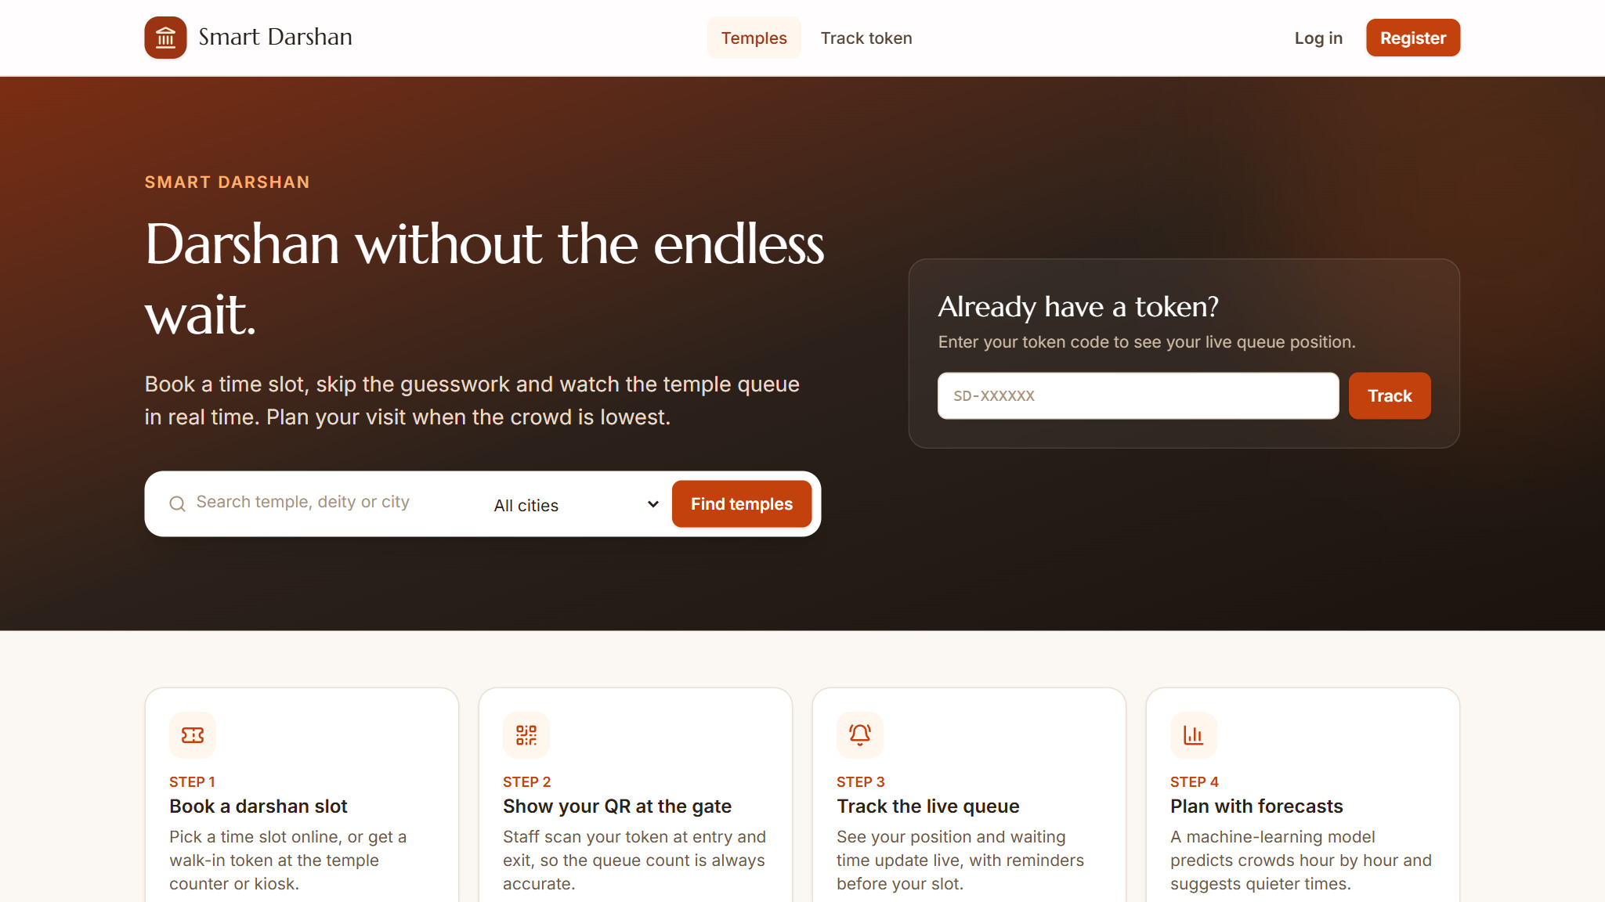
Fig S.1: Home page with the live waiting time of each temple
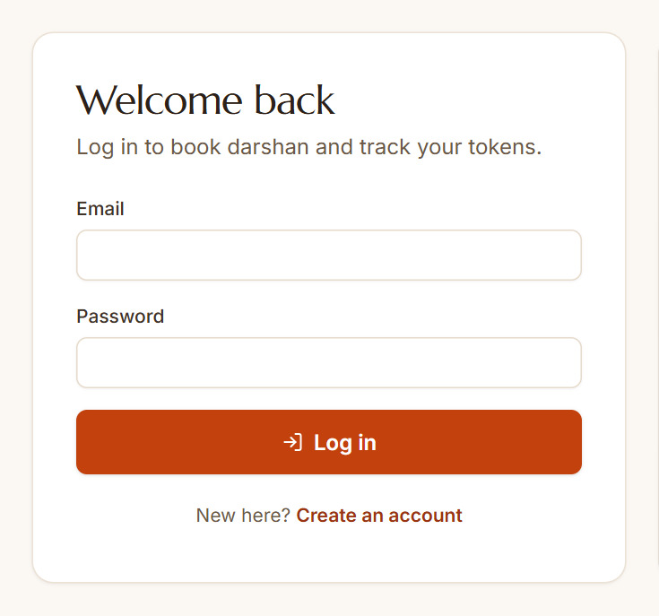
Fig S.2: Login page
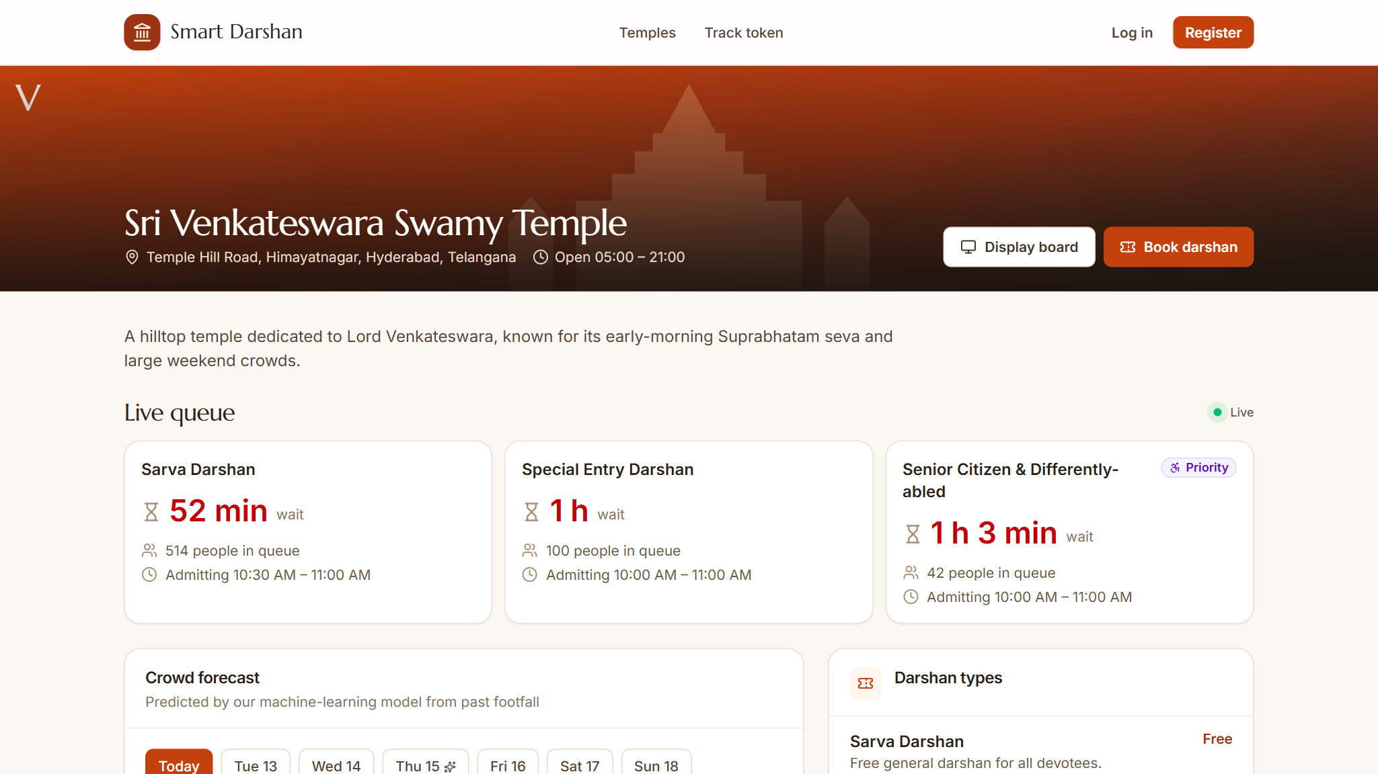
Fig S.3: Temple page – live queue of each darshan lane
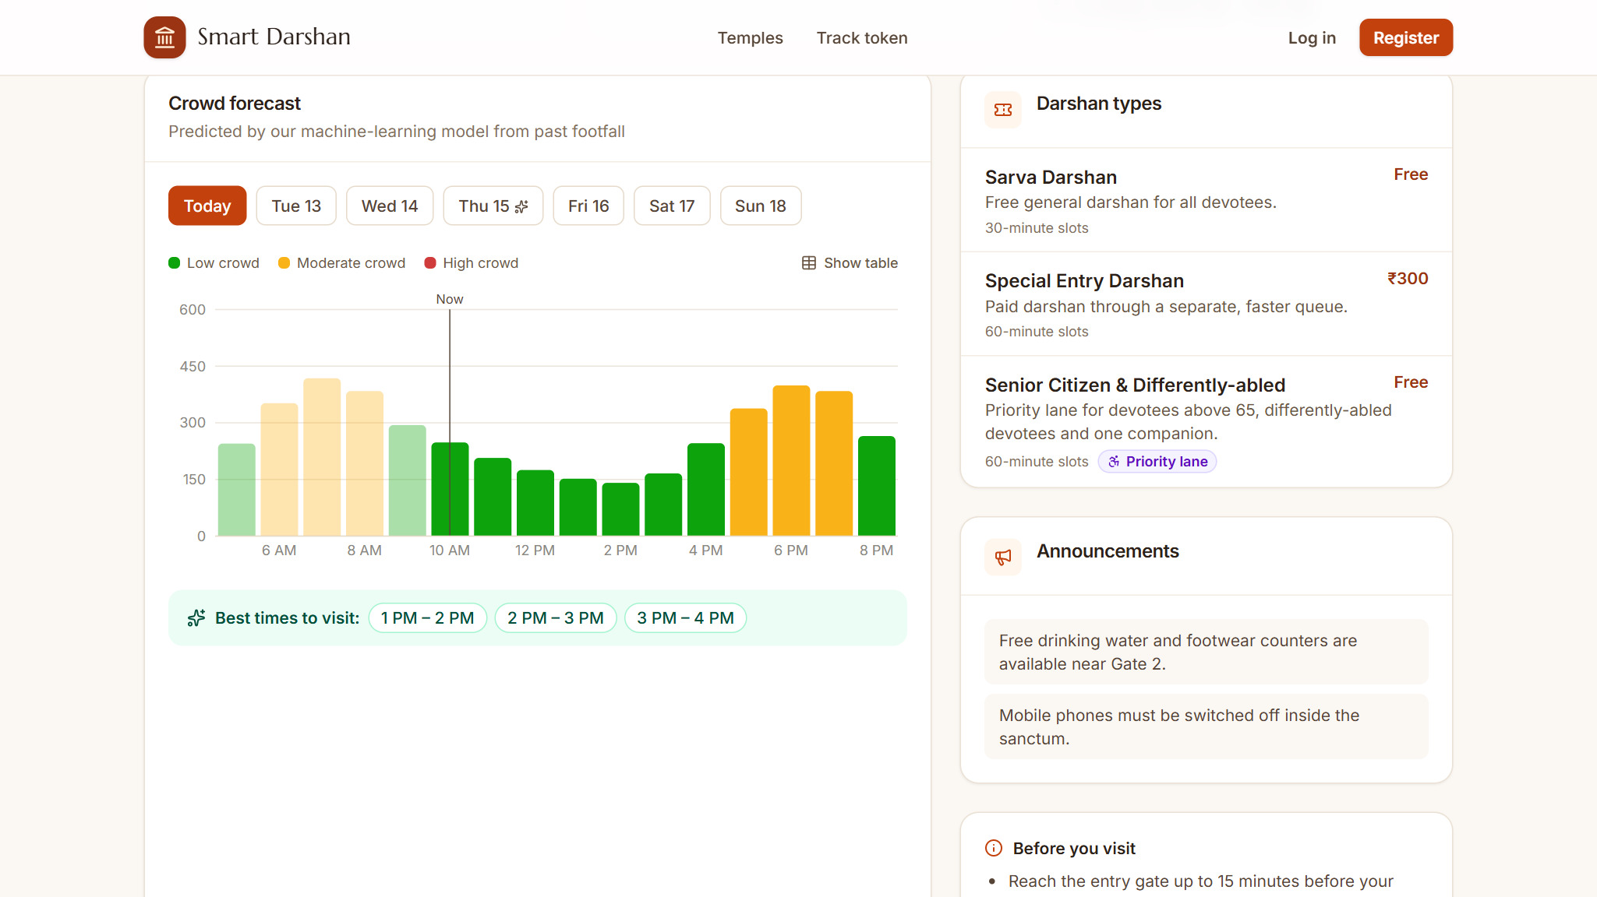
Fig S.4: Temple page – hourly crowd forecast, darshan types and announcements
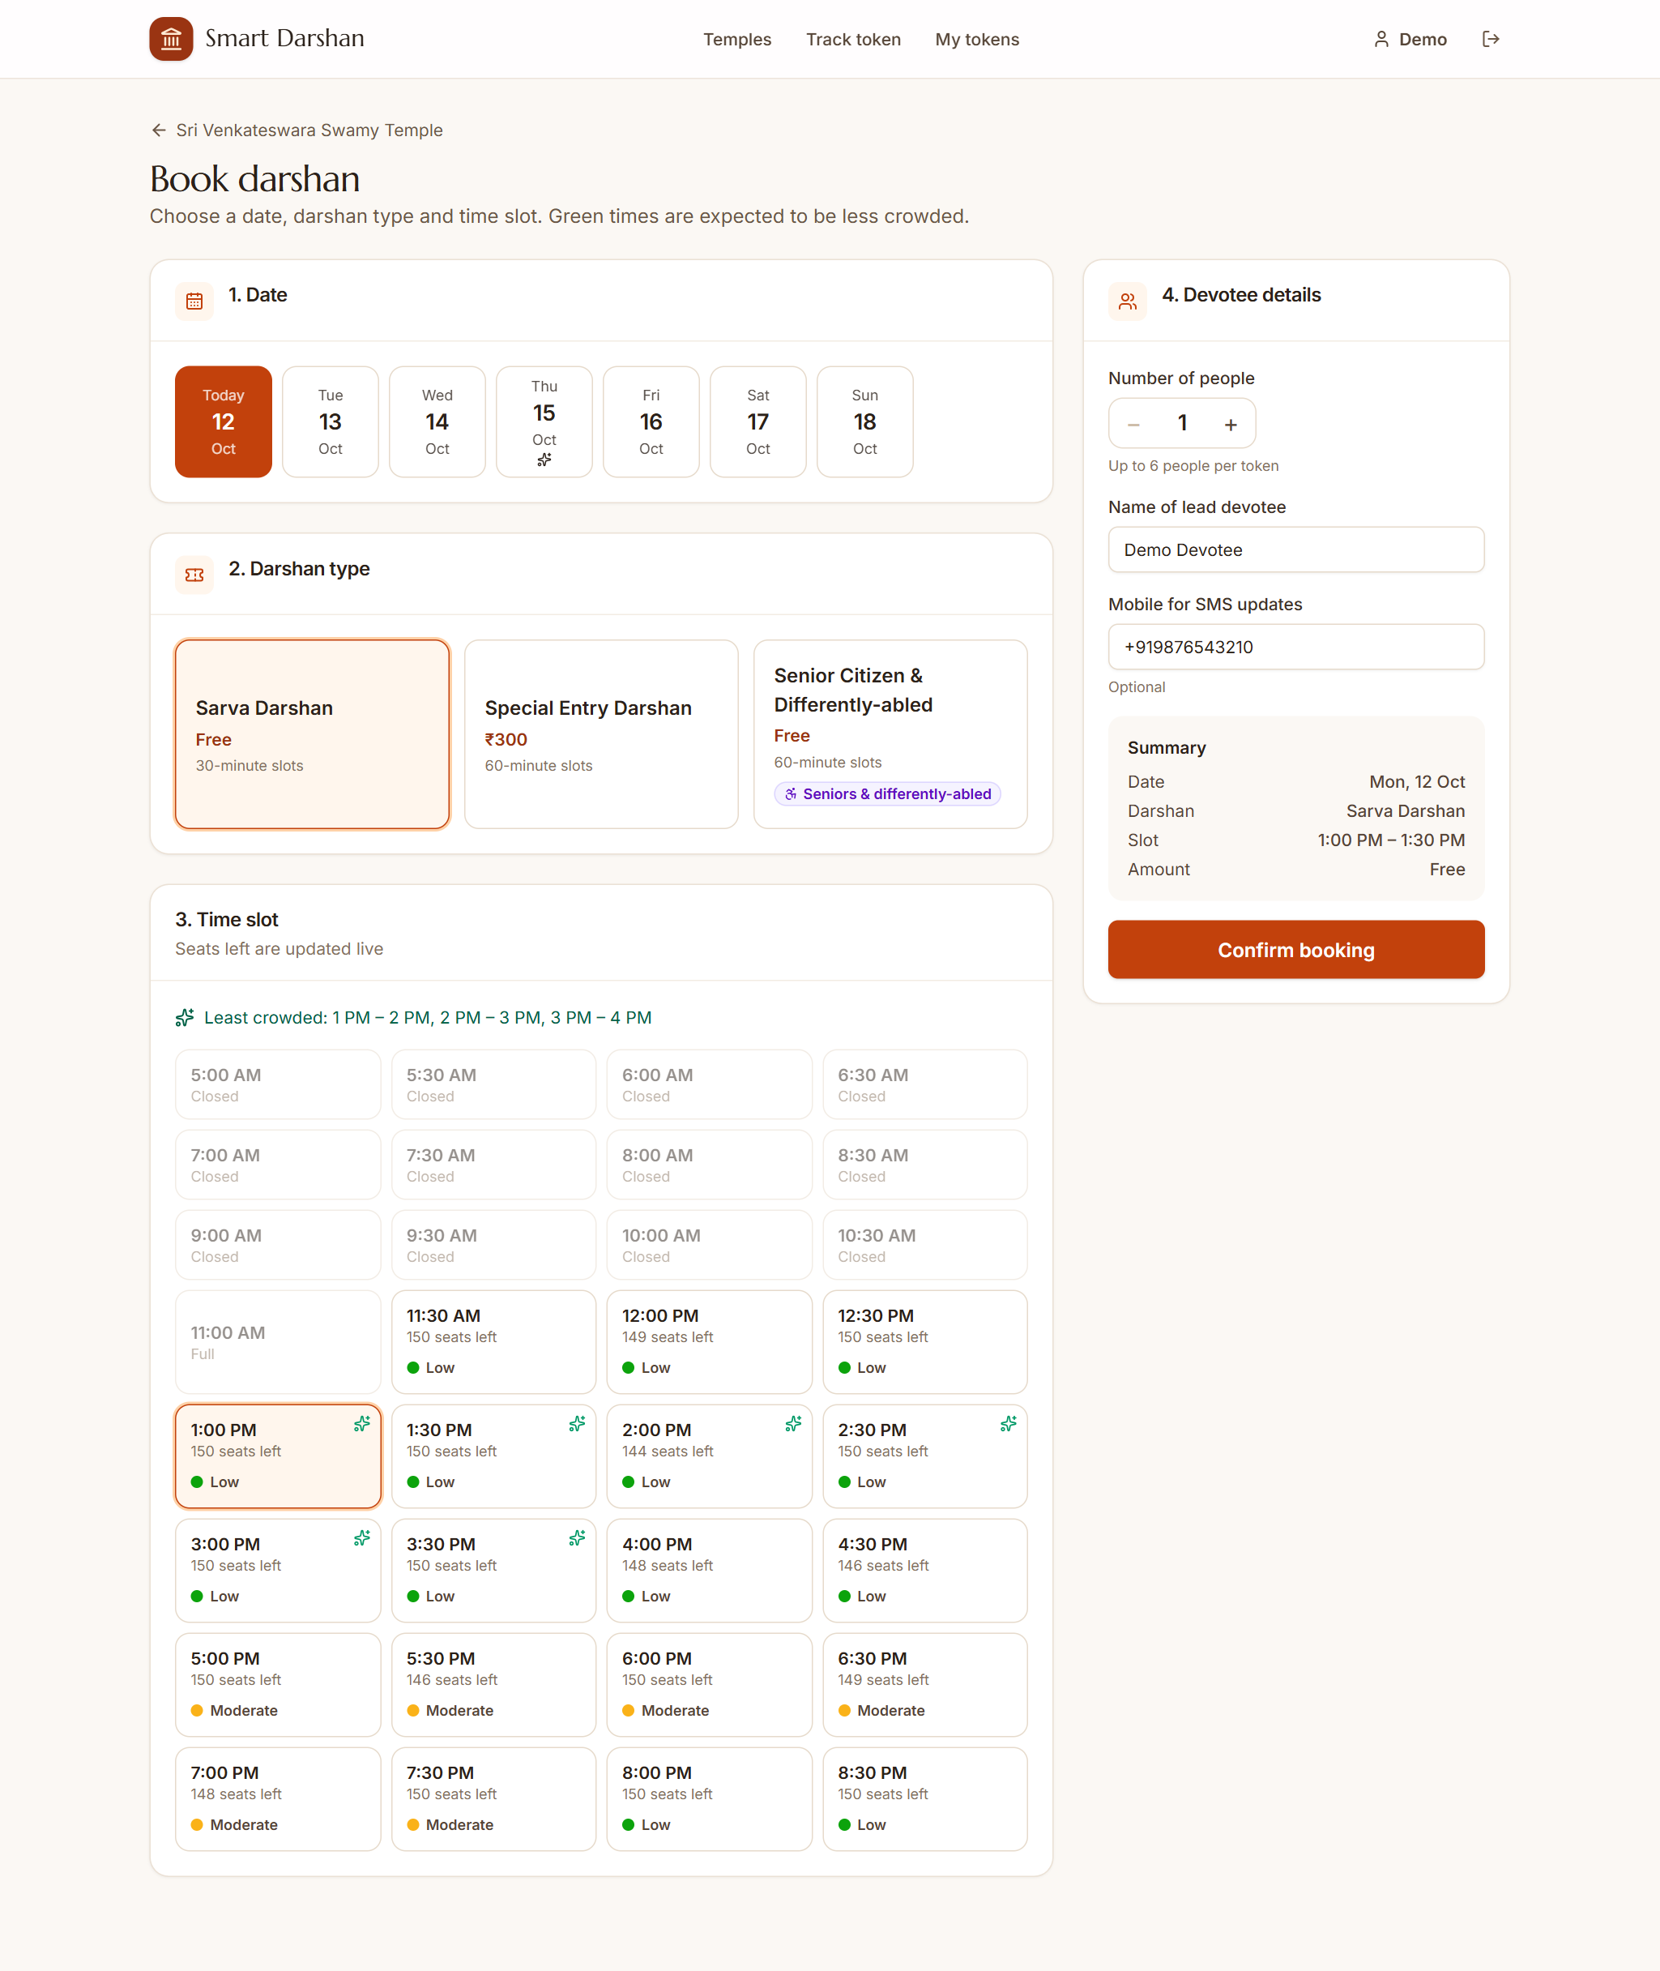
Fig S.5: Booking a darshan slot with crowd-coloured time slots
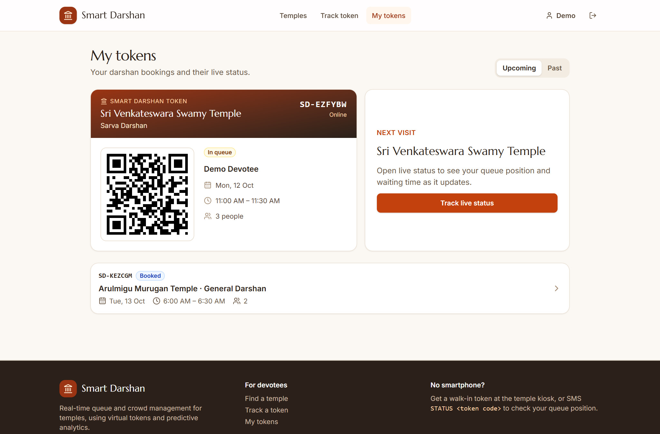
Fig S.6: My tokens – QR-coded digital token
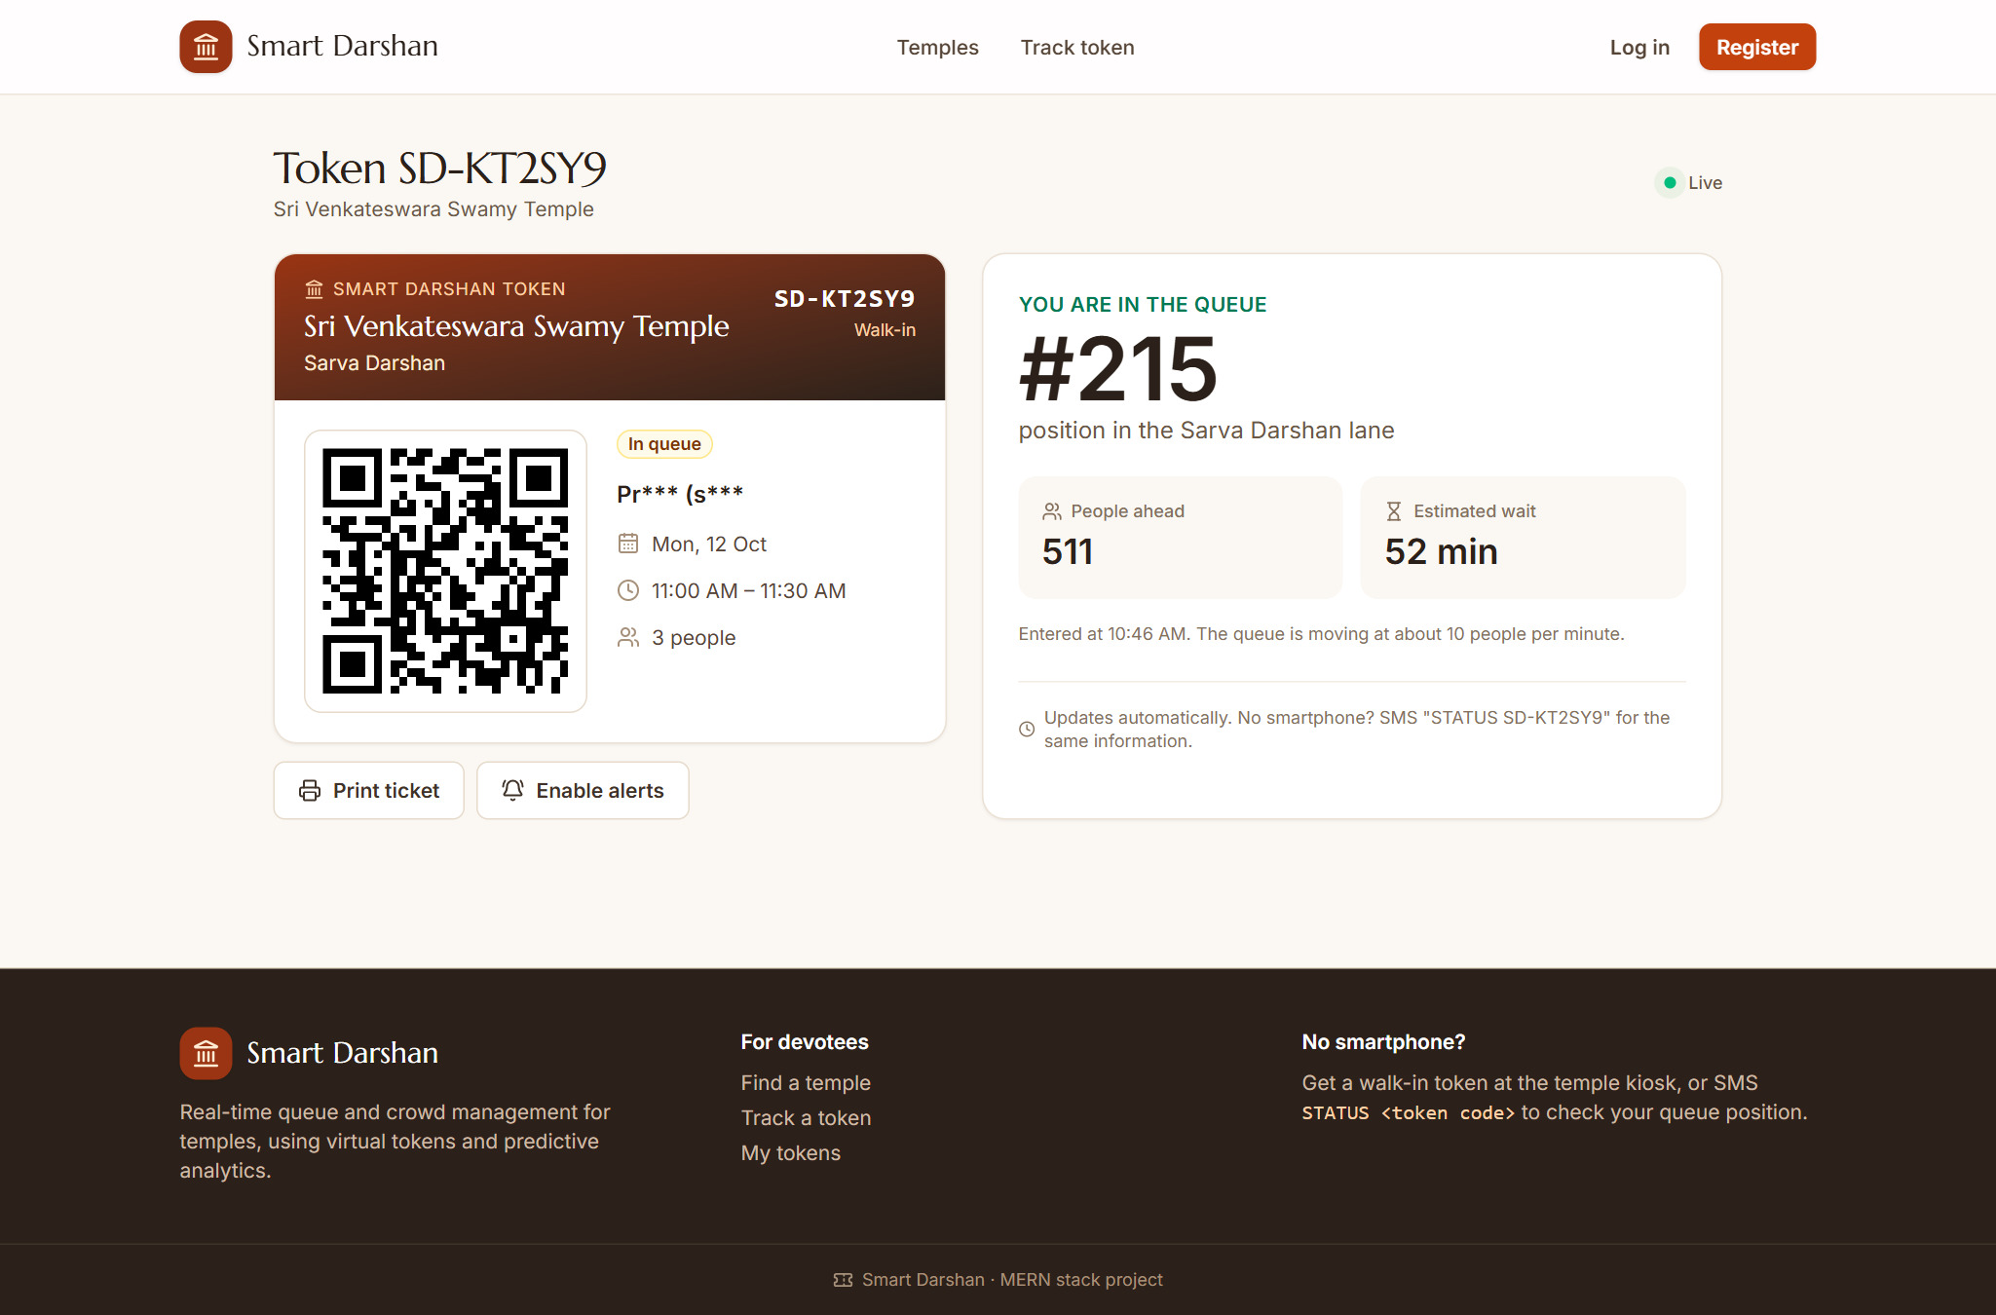
Fig S.7: Live token status – queue position and estimated wait
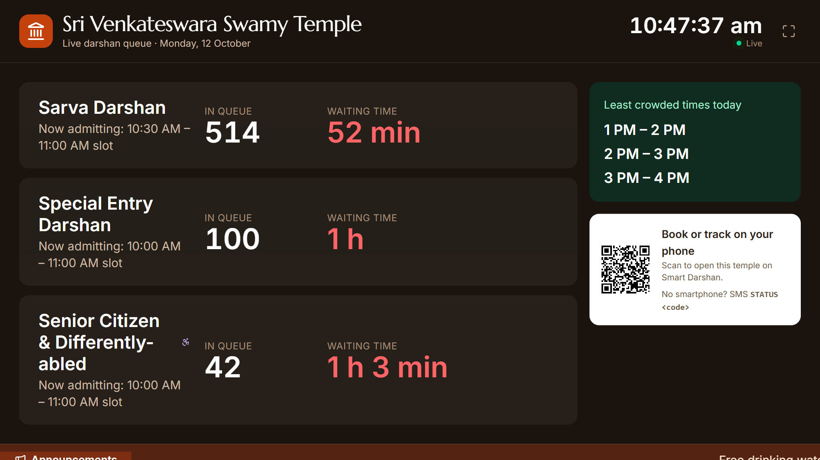
Fig S.8: Entry display board
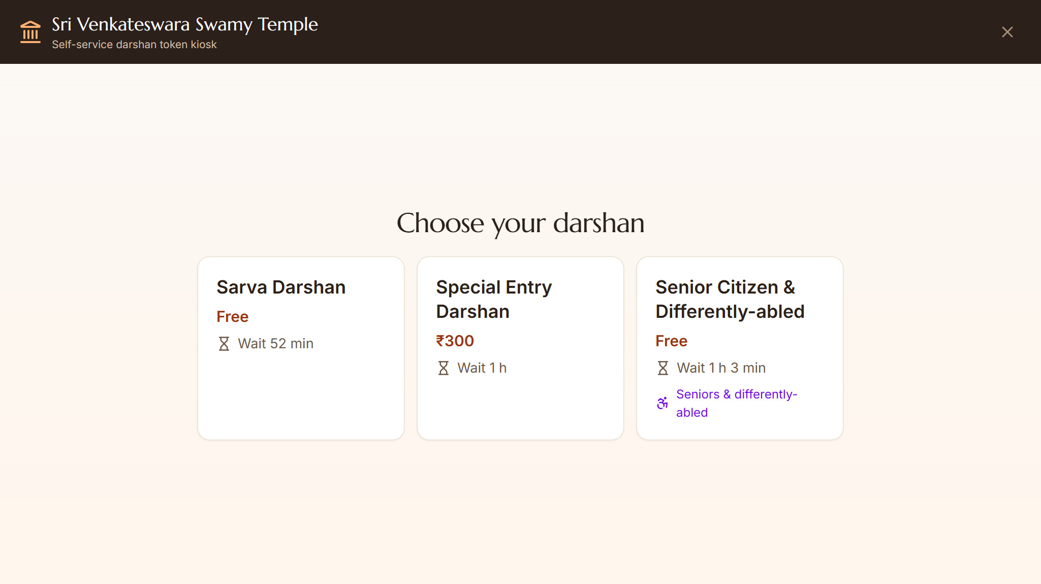
Fig S.9: Self-service kiosk – choosing a darshan type
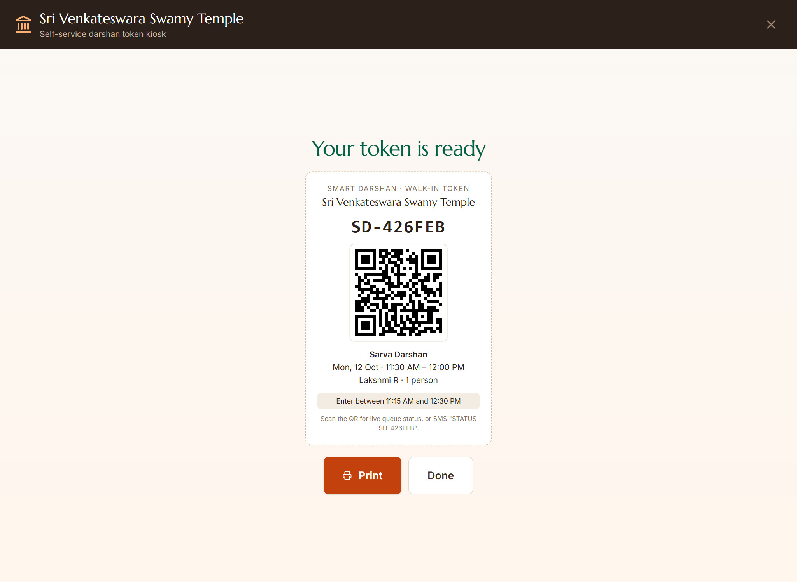
Fig S.10: Self-service kiosk – token issued with QR code
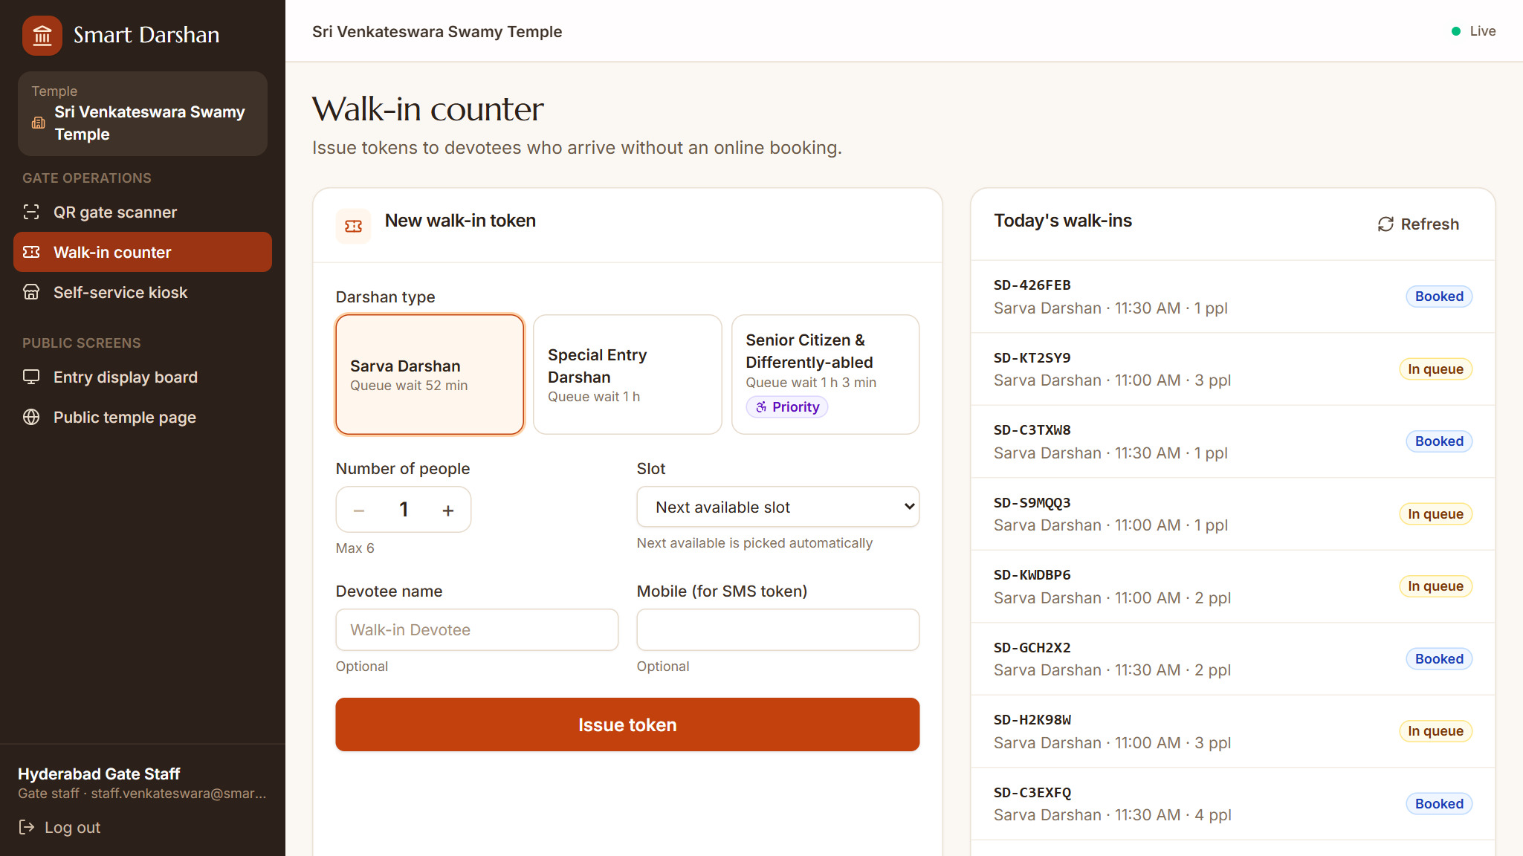
Fig S.11: Walk-in counter
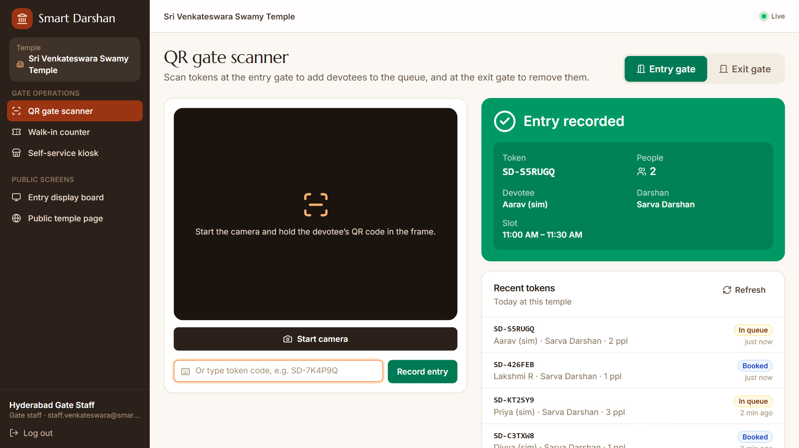
Fig S.12: QR gate scanner – entry recorded
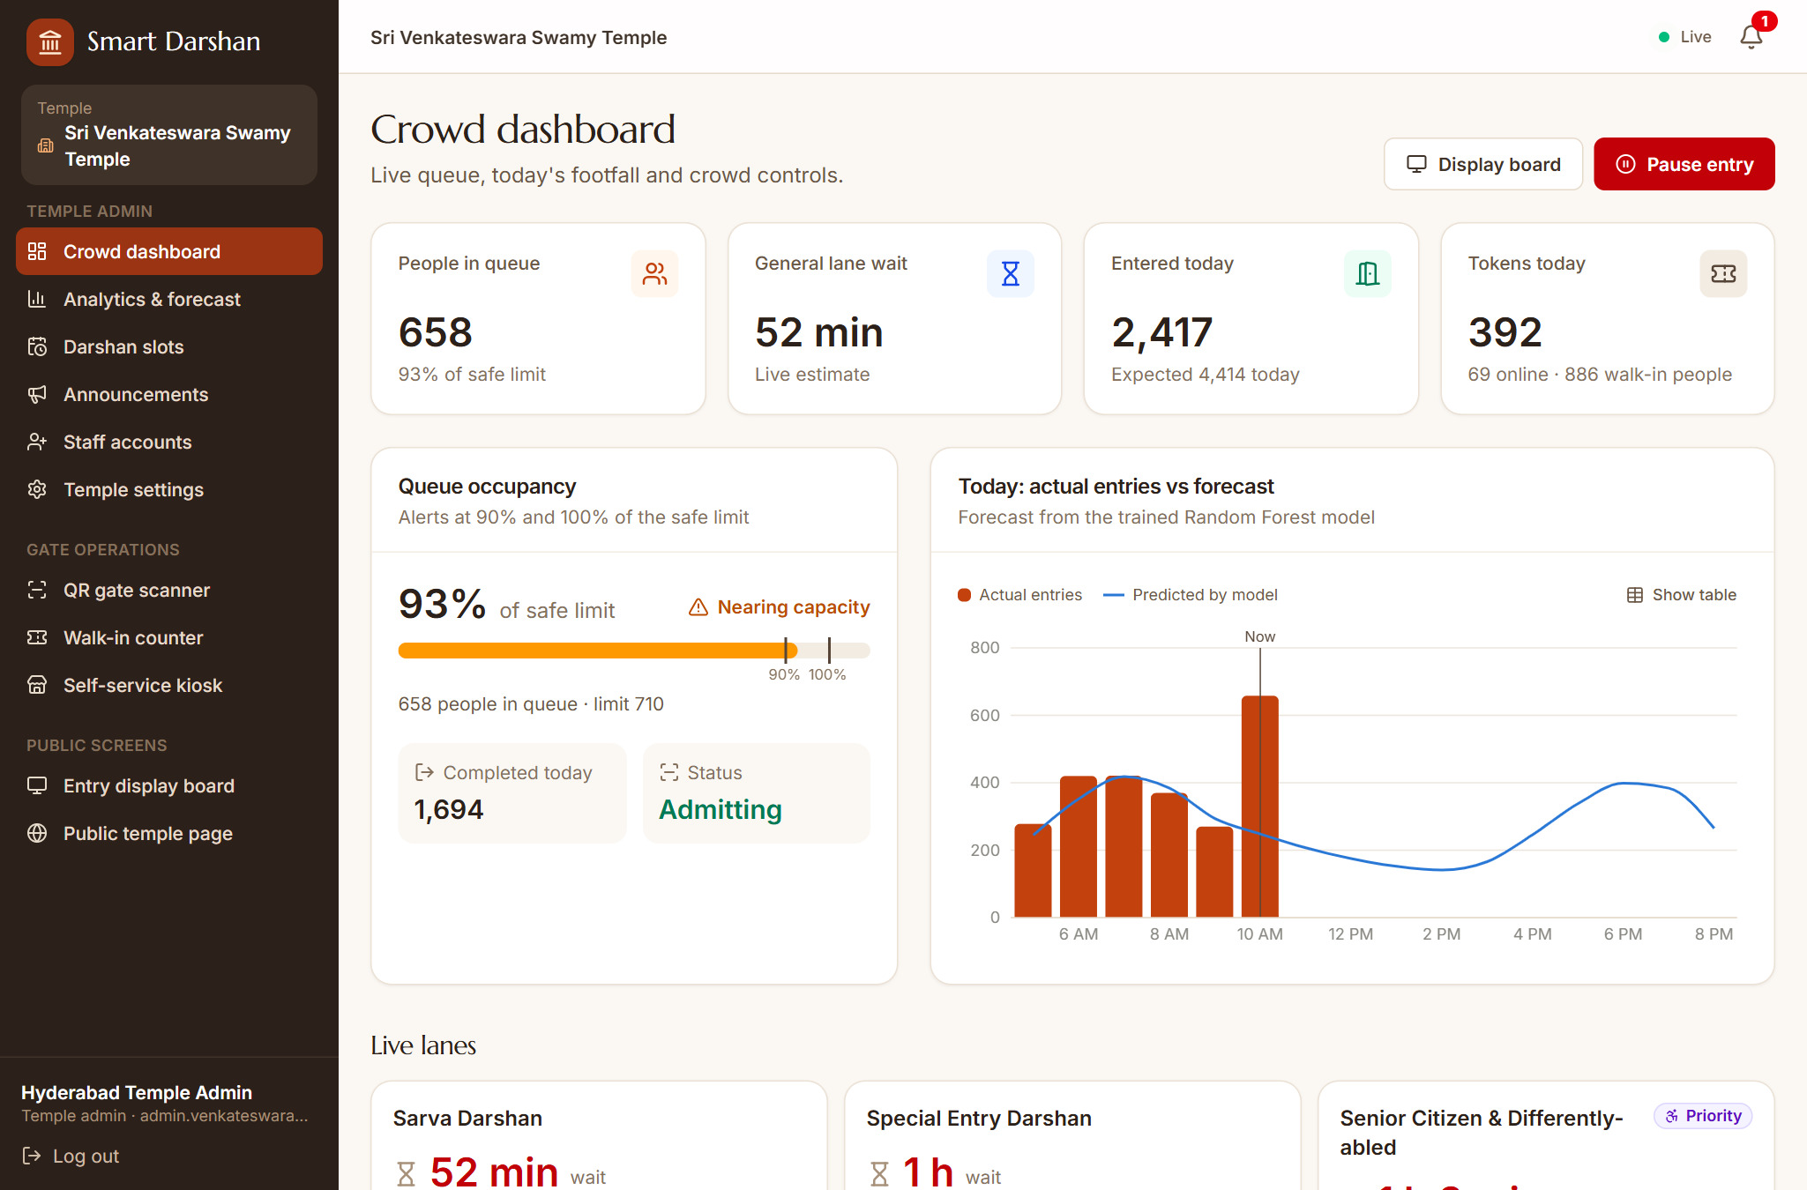
Fig S.13: Crowd dashboard
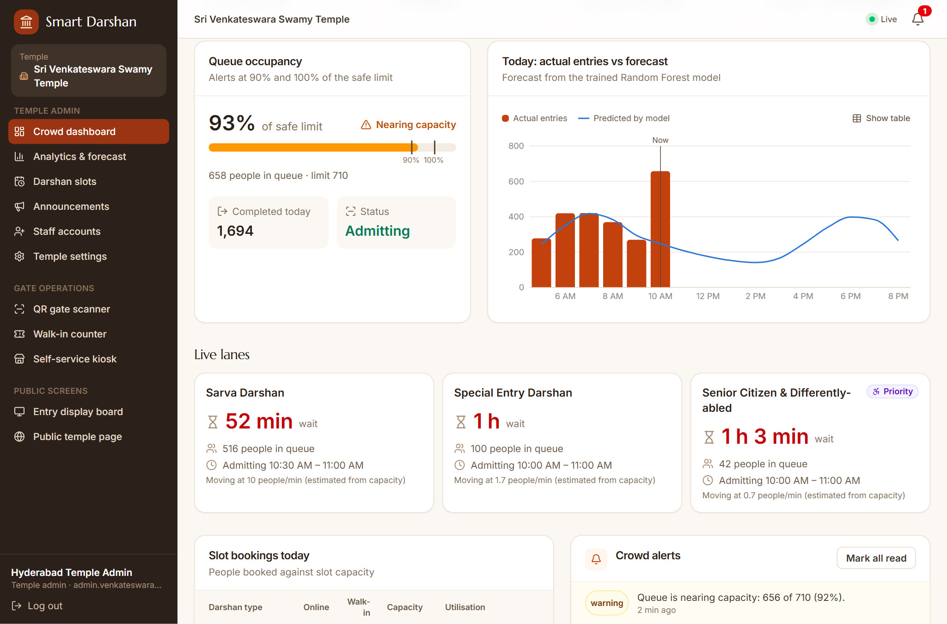
Fig S.14: Crowd dashboard – occupancy, actual versus predicted footfall and live lanes
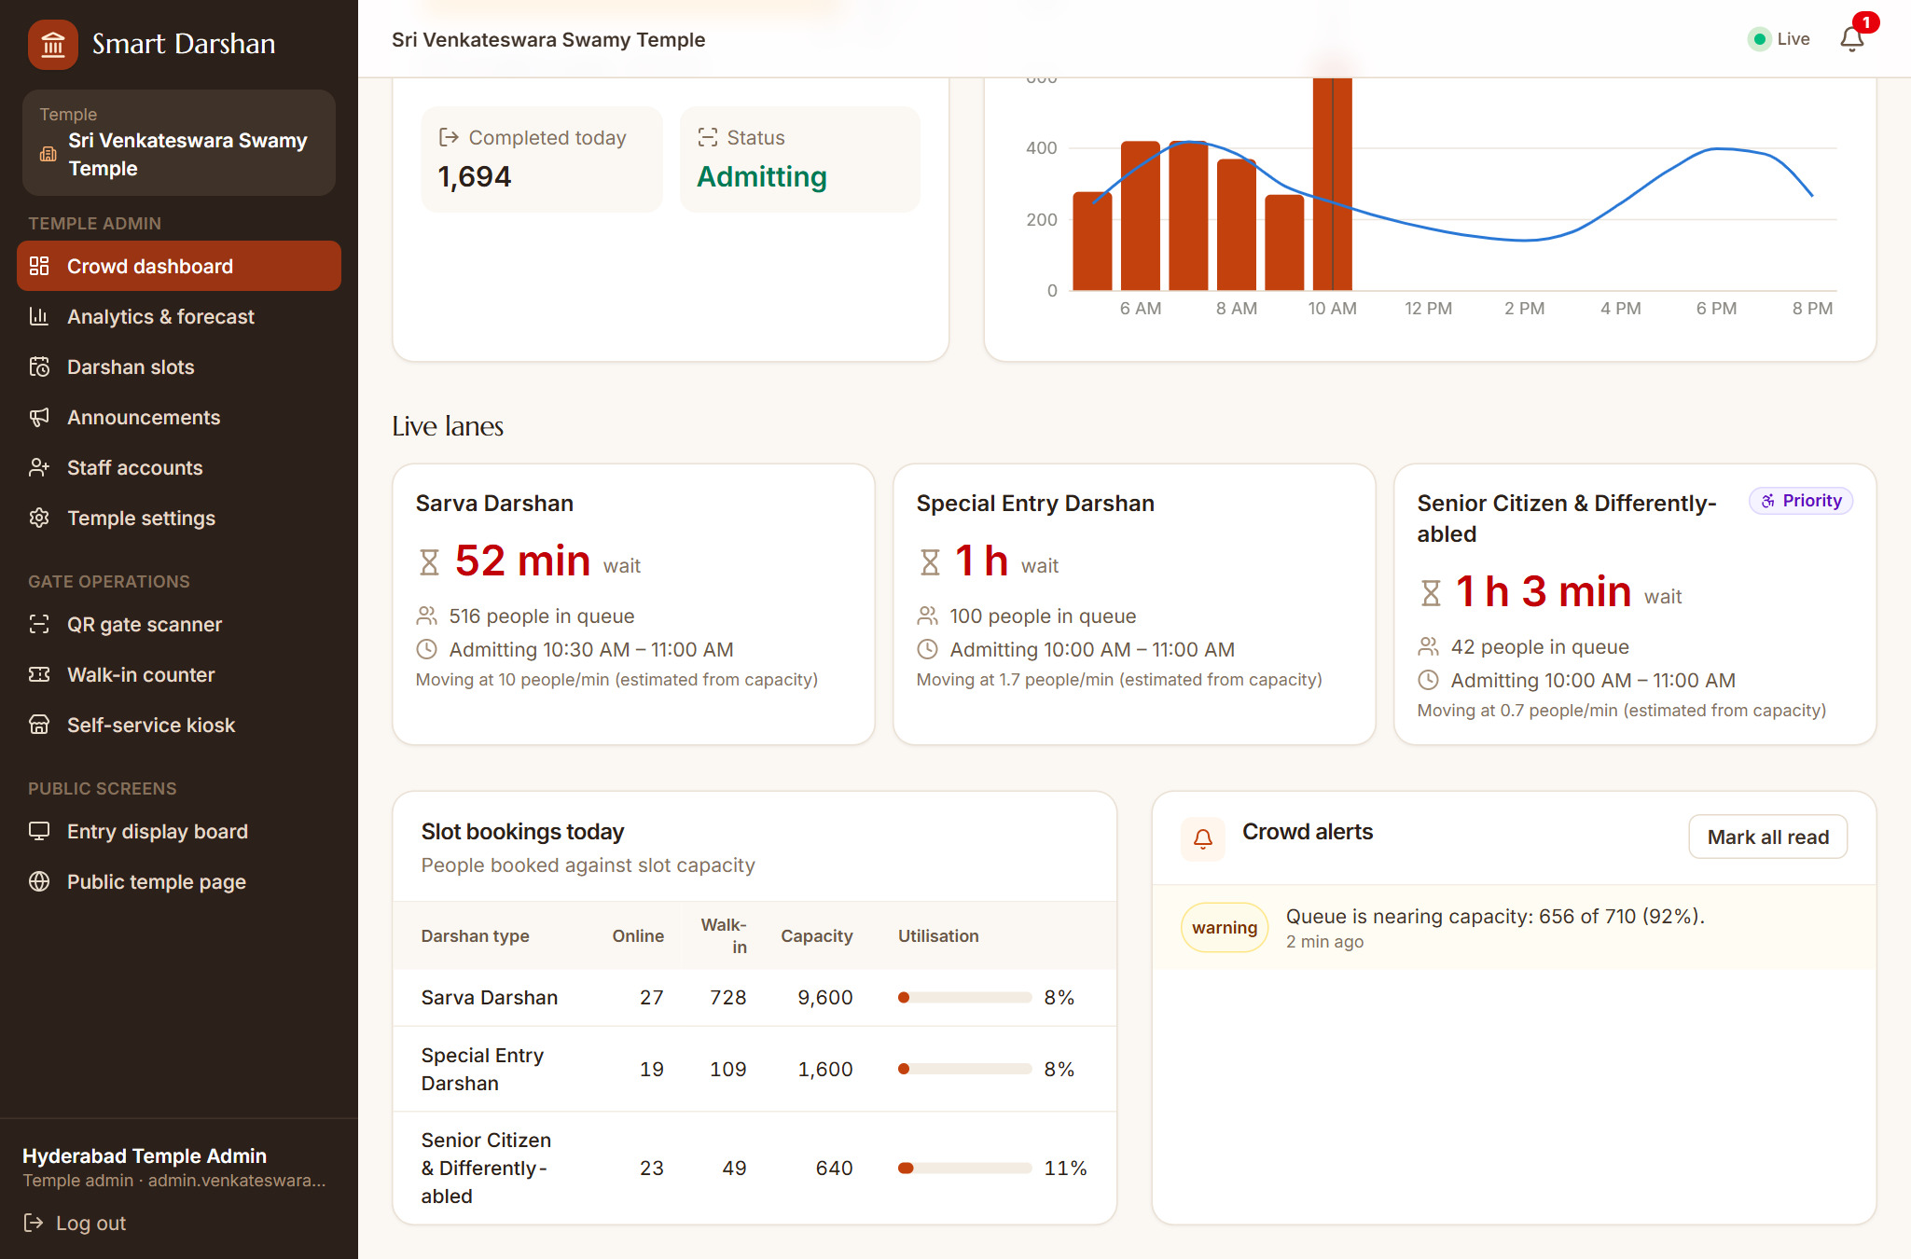
Fig S.15: Crowd dashboard – slot bookings and an occupancy alert
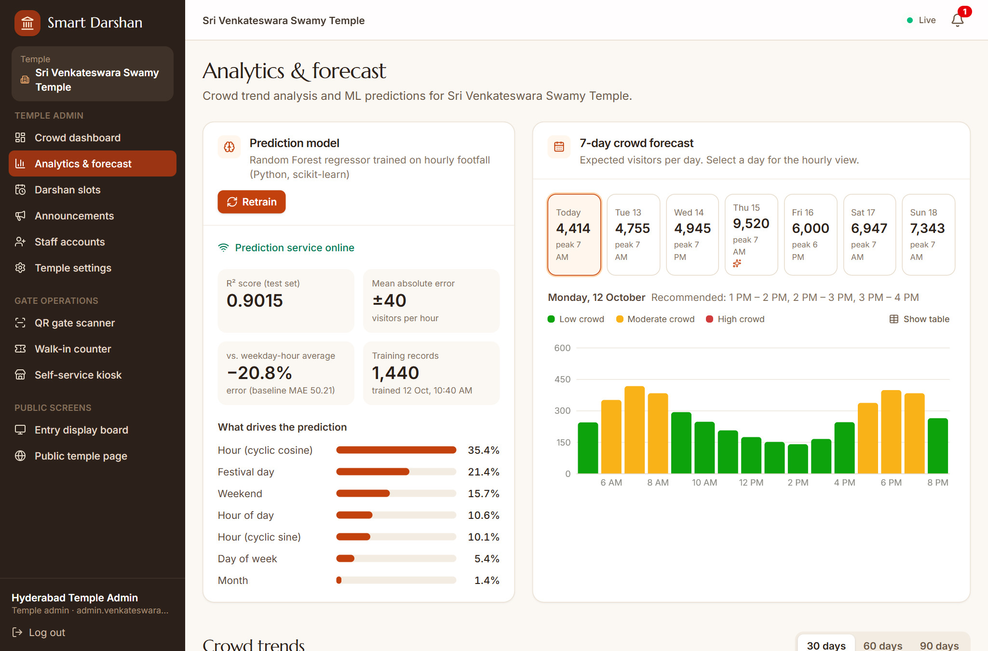
Fig S.16: Analytics – prediction model accuracy and feature importance
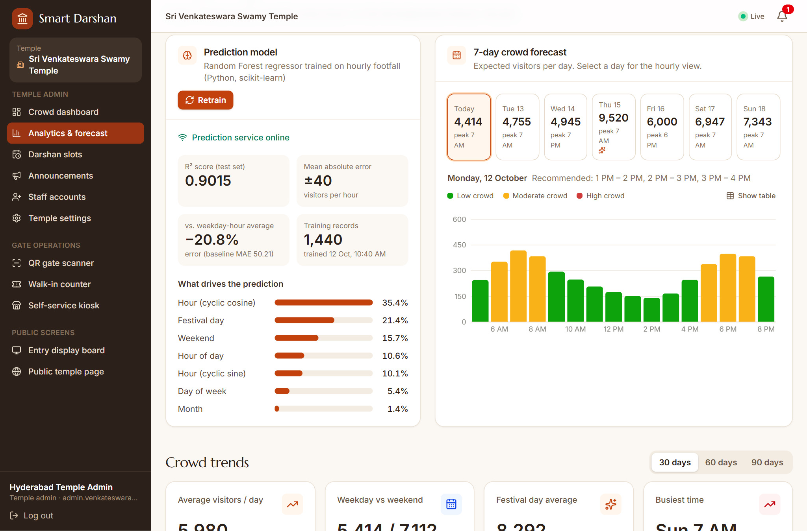
Fig S.17: Analytics – 7-day crowd forecast
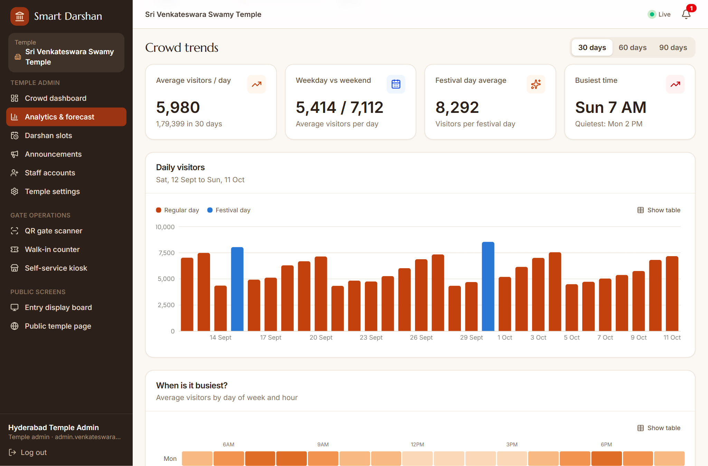
Fig S.18: Analytics – crowd trends and daily visitors
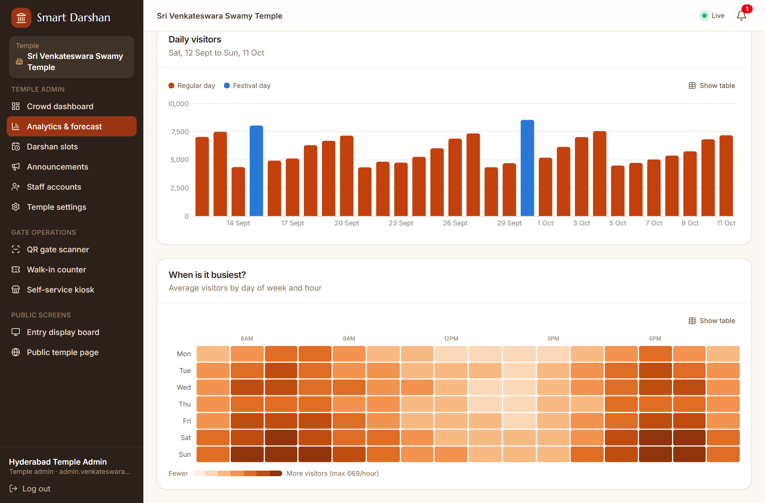
Fig S.19: Analytics – busiest days and hours
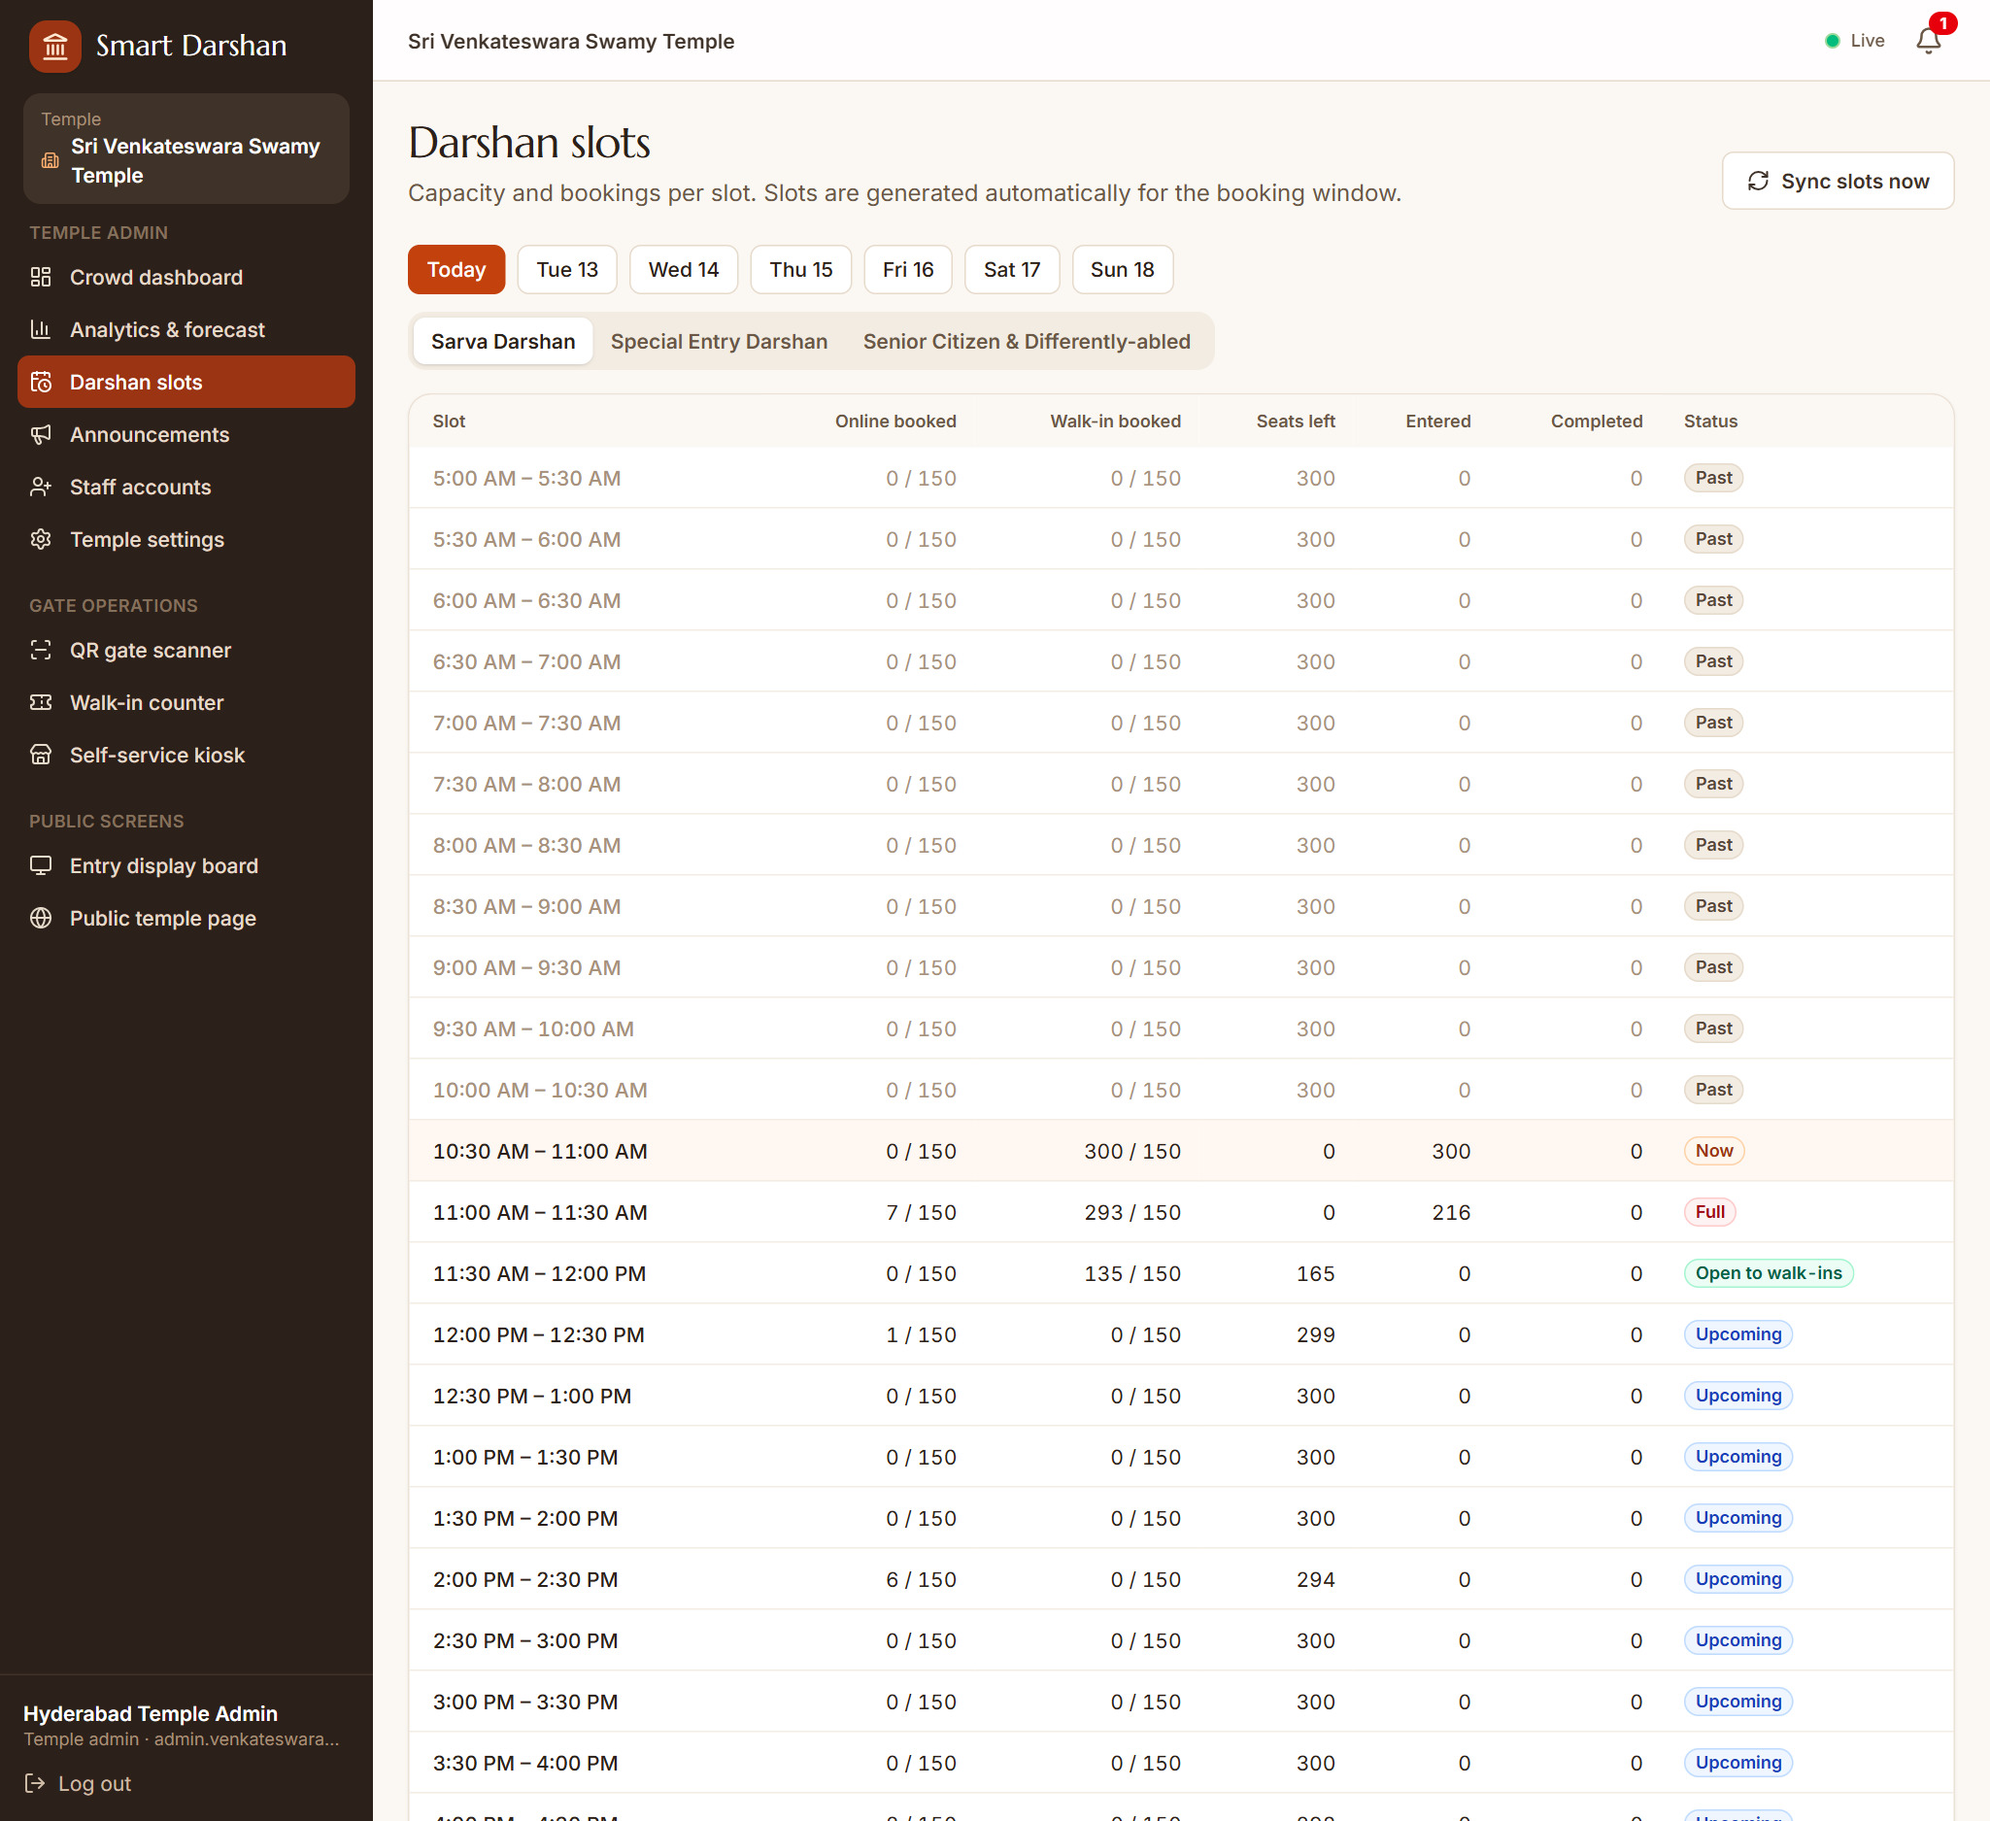
Fig S.20: Darshan slot management
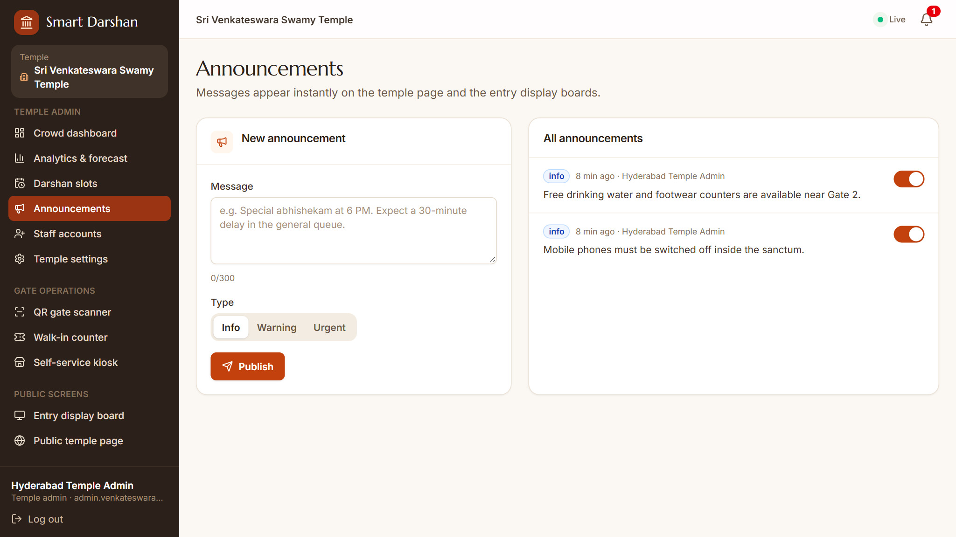
Fig S.21: Announcements
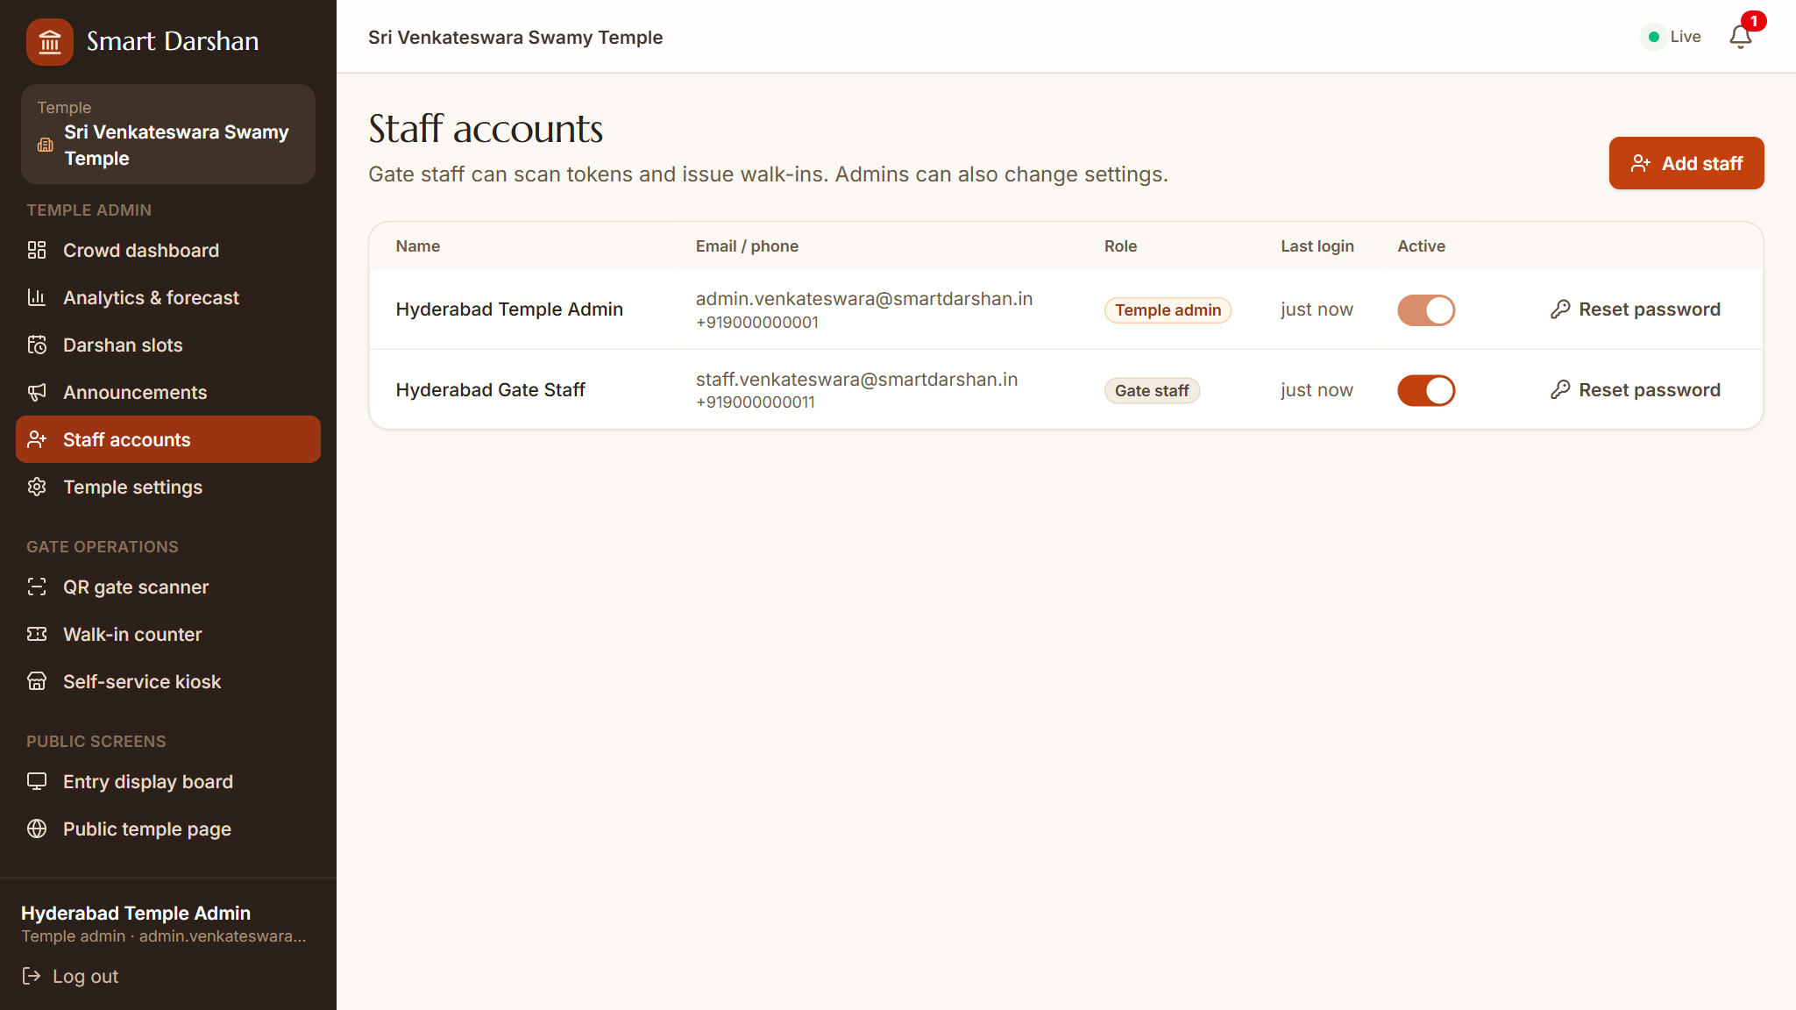
Fig S.22: Staff accounts
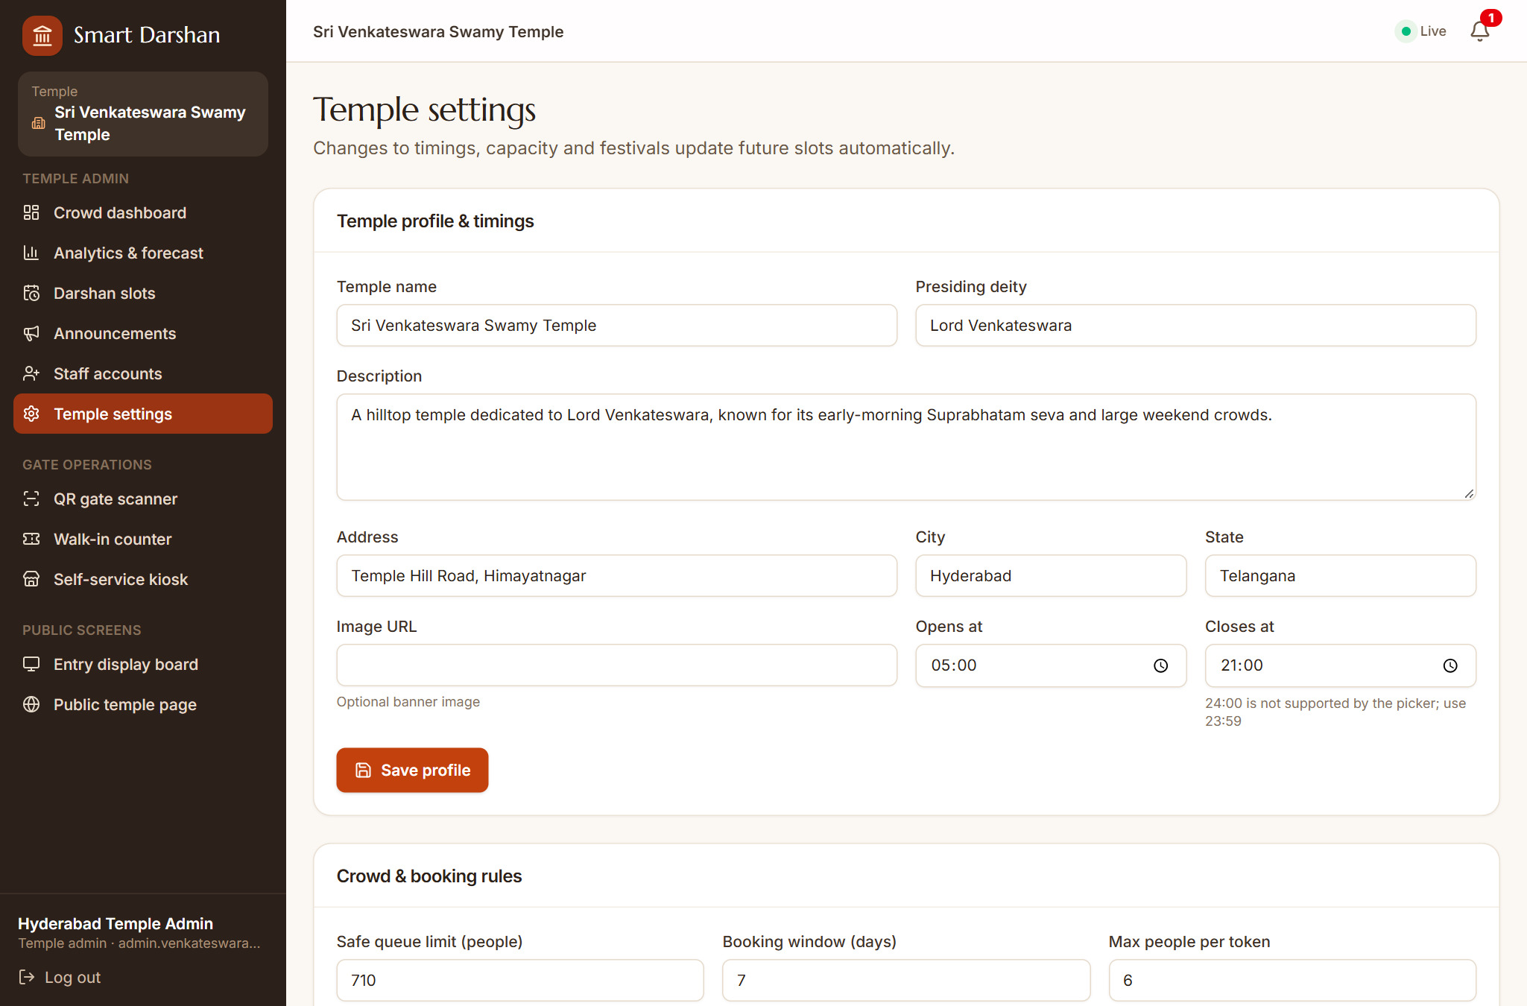
Fig S.23: Temple settings
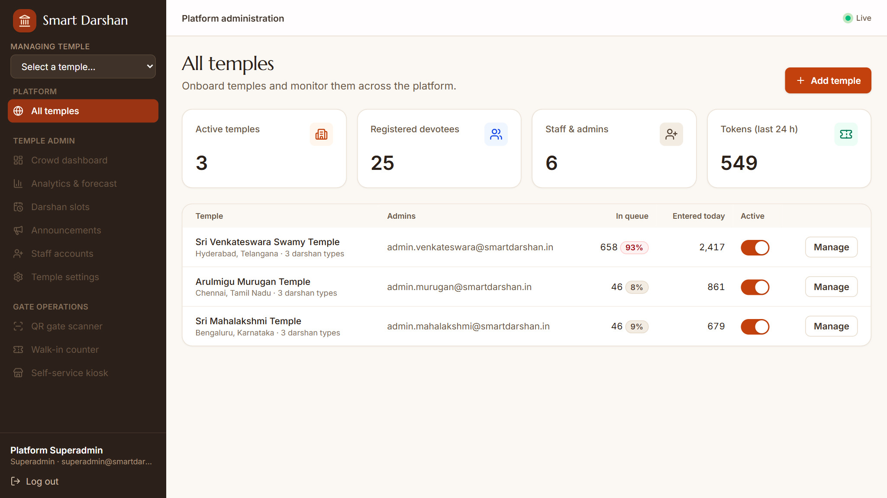
Fig S.24: Superadmin – all temples

REFERENCES
[1] M. R. Bhuiyan, J. Abdullah, N. Hashim, F. Al Farid, J. Uddin, N. Abdullah and M. A. Samsudin, “Crowd density estimation using deep learning for Hajj pilgrimage video analytics,” F1000Research, vol. 10, p. 1190, 2022.
[2] S. Kawade, R. Pawar, S. Shewale, V. Tatar and S. R. Bhor, “Temple Crowd Management and Elevation System Using IoT,” IJSRD – International Journal for Scientific Research & Development, vol. 13, no. 2, 2025.
[3] M. D. Reddy, K. Narasimha and Lakshmi Kumari, “Smart Slot-Based Darshan Management System (Rapid Darshan),” International Journal of Engineering Research & Technology (IJERT), vol. 15, no. 5, 2026.
[4] Q. Yu, Y. Zhang and Y.-P. Zhou, “Delay Information in Virtual Queues: A Large-Scale Field Experiment on a Major Ride-Sharing Platform,” Management Science, 2022. doi:10.1287/mnsc.2022.4448.
[5] KPMG in India, “Faith and Flow: Navigating Crowds in India’s Sacred Spaces,” Aug. 2025. [Online]. Available: https://kpmg.com/in/en/insights/2025/08/faith-and-flow-navigating-crowds-in-indias-sacred-spaces.html
[6] J. D. C. Little, “A Proof for the Queuing Formula: L = λW,” Operations Research, vol. 9, no. 3, pp. 383–387, 1961.
[7] L. Breiman, “Random Forests,” Machine Learning, vol. 45, no. 1, pp. 5–32, 2001.
[8] F. Pedregosa et al., “Scikit-learn: Machine Learning in Python,” Journal of Machine Learning Research, vol. 12, pp. 2825–2830, 2011.
[9] M. Jones, J. Bradley and N. Sakimura, “JSON Web Token (JWT),” RFC 7519, Internet Engineering Task Force, May 2015.
[10] N. Provos and D. Mazières, “A Future-Adaptable Password Scheme,” in Proc. USENIX Annual Technical Conference (FREENIX Track), 1999.
[11] MongoDB, Inc., “MongoDB Manual.” [Online]. Available: https://www.mongodb.com/docs/manual/
[12] Mongoose, “Mongoose Documentation.” [Online]. Available: https://mongoosejs.com/docs/
[13] OpenJS Foundation, “Express – Node.js web application framework.” [Online]. Available: https://expressjs.com/
[14] Meta Platforms, Inc., “React Documentation.” [Online]. Available: https://react.dev/
[15] Socket.IO, “Socket.IO Documentation (v4).” [Online]. Available: https://socket.io/docs/v4/
[16] scikit-learn developers, “RandomForestRegressor – scikit-learn documentation.” [Online]. Available: https://scikit-learn.org/stable/modules/generated/sklearn.ensemble.RandomForestRegressor.html
[17] Twilio Inc., “Programmable Messaging Documentation.” [Online]. Available: https://www.twilio.com/docs/messaging

